**COMPUTER STUDIES GOVERNMENT PROJECT MANAGEMENT SYSTEM**

**SOFTWARE REQUIREMENTS SPECIFICATION**

**Team Name :** House of Megan

**Section :** S23

**Team Members:** Avanceña, Margaret Ann

Bautista, Carlo Migel

Chua, Ralph

Dimanarig, Edgar

Garcia, Daniel Jaspher

Mañalac, Miguel Iñigo

Medel, Rheygine Kim

Ongsingco, Joseph

Partosa, Brandon

Tiu, Kenywil

**Date Submitted:** February 12, 2016

**TABLE OF CONTENTS**

|  |  |  |
| --- | --- | --- |
|  | 1 Executive Summary | 1-1 |
|  | 2 Overview | 2-1 |
|  | 2.1 Existing Business Process | 2-1 |
|  | 2.2 Data Requirements | 2-2 |
|  | 2.3 Roles in the Business Process | 2-3 |
|  | 3 Problem Analysis | 3-1 |
|  | 4 Software Solution | 4-1 |
|  | 4.1 Objectives | 4-1 |
|  | 4.2 Characteristics | 4-1 |
|  | 5 User Stories | 5-1 |
|  | 5.1 User Story 1 | 5-1 |
|  | 5.2 User Story 2 | 5-2 |
|  | 5.3 User Story 3 | 5-3 |
|  | 5.4 User Story 4 | 5-4 |
|  | 5.5 User Story 5 | 5-5 |
|  | 5.6 User Story 6 | 5-6 |
|  | 5.7 User Story 7 | 5-7 |
|  | 5.8 User Story 8 | 5-8 |
|  | 5.9 User Story 9 | 5-9 |
|  | 5.10 User Story 10 | 5-10 |
|  | 5.11 User Story 11 | 5-11 |
|  | 5.12 User Story 12 | 5-12 |
|  | 5.13 User Story 13 | 5-13 |
|  | 5.14 User Story 14 | 5-14 |
|  | 5.15 User Story 15 | 5-15 |
|  | 5.16 User Story 16 | 5-16 |
|  | 5.17 User Story 17 | 5-17 |
|  | 5.18 User Story 18 | 5-18 |
|  | 5.19 User Story 19 | 5-19 |
|  | Appendix A - Improved Business Plan | A-1 |
|  | Appendix B - Interview Transcript | B-1 |
|  | Appendix C - Sample Forms and Reports | C-1 |
|  | Appendix D - Requirements Checklist | D-1 |
|  | Appendix E - References and Acknowledgements | E-1 |

**1 Executive Summary**

Computer Studies Government, also known as the CSG, is a college-wide organization that focuses on the development of the entire College of Computer Studies (CCS), including the undergraduate students under it. CSG is composed of undergraduate students taking courses under CCS that have went through the application process. Students with the desire to be part of an organization that centers on college-wide development and the eagerness to gain leadership skills are welcome to join.

CSG plans, organizes and conducts various student activities for the benefit of the undergraduate students. By regulating peer tutorials, the organization aims to help the students with their academics and with the hope of getting their grades up. By organizing seminars and talks, the organization intends on informing the students with updates and relevant news in the IT industry. And by conducting charity events, the organization wishes to teach the students the true meaning of being a Lasallian by helping the less fortunate.

CSG officers are the ones responsible for the planning and execution of these activities. It is their duty to accomplish the necessary documents, to pass them to the office assigned to handle all the paperwork, and to execute the events and activities successfully. By applying to become a CSG officer, it is their job to achieve the main goal of the organization: to promote college-wide development.

**2 Overview of the Business Process**

*In this section, the current business process of the Computer Studies Government is discussed as well as the data required during the process and the different roles in the business process.*

**2.1 Existing Business Process**

Currently, the business process of the Computer Studies Government can be segregated into four phases — conceptualization of the project, preparation prior the event, execution of the event, completion of the project.

**A.** **Conceptualization of the Project**

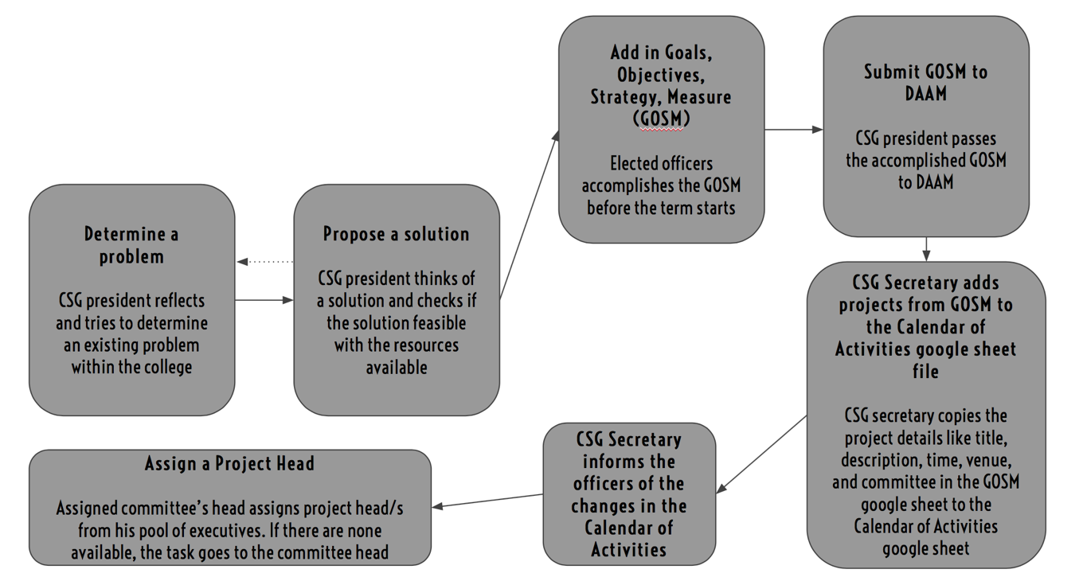

During the initial interview with the President, there is no exact process as to how they determine a problem in the college. The president simply reflects and tries to determine an existing problem. After that, he proposes solution whether or not it is feasible. If it is not, he tries to determine another problem and propose a solution again. If proposed solution is feasible, they add it to the GOSM (Goals, Objectives, Strategy, Measure), which is completed and submitted to DAAM at the beginning of the term. After the GOSM has been completed, the CSG secretary can now add the projects it to the Calendar of activities with the following project details: Nature of activity, Type of Activity, Goal, Objectives, Strategy (Title), Description, Measure, Dates, Unit-in-Charge and Committee, which is located at the google drive as a google sheet file. Officers and the committee heads are then informed of the change in the Calendar of activities and the committee head then assigns a project head under his committee then add the necessary information under Project Head in the calendar of activities. If there is no available for handling a project, the task will go to the committee head.

**B.** **Preparation prior the Event**

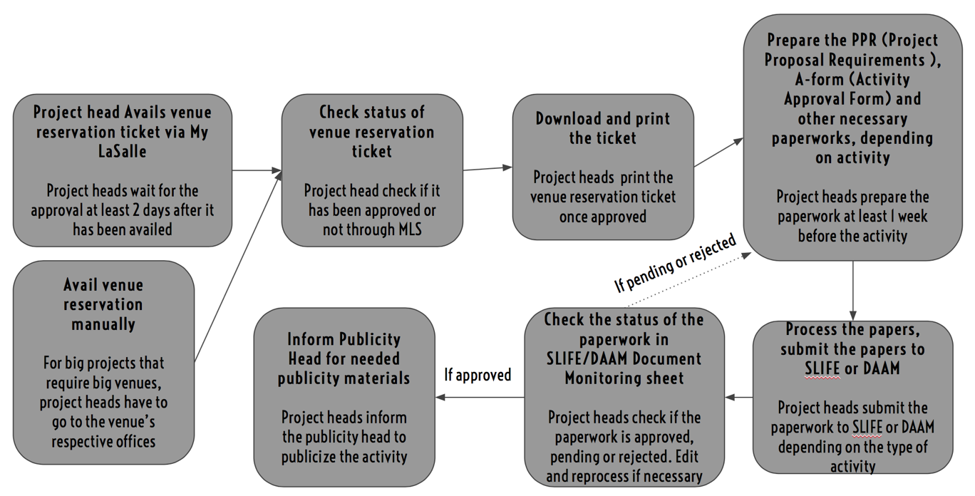

Before the event, the assigned project head must avail of a venue reservation ticket from MyLaSalle if the venue could be reserved through there, otherwise, they must manually reserve a venue by going to the office concerned. It takes at least 2 days for the venue ticket to get approved. If it has been approved, you can now download and print the ticket. After that, project head can now prepare and process the 2 other main papers, the pre-activity paper and activity approval form, as well as the other necessary documents that permits processing depending on the nature of activity and type of activity. After the papers have been prepared, it should be passed on to SLIFE or DAAM, depending on what the activity calls for. Project head should check on the SLIFE / DAAM document monitoring google sheet for the status of their papers. If they have been approved, activity can now be publicized. If pended or rejected, they must prepare the documents with the necessary corrections.

**C.** **Execution of the Event**

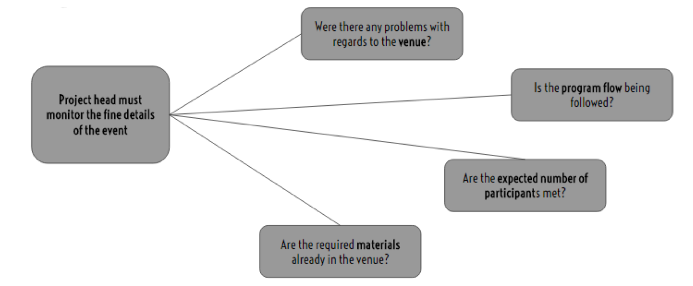

During the event, the project heads appointed must monitor whether the program is going smooth. They have a lot of tasks to do. One of those tasks is to verify if the venue has no problems and whether the materials needed are in the venue before the start of the program. Next is they have to set up the venue (with the help of fellow officers) in accordance to their program. They have to check if all of the equipments are in proper working order. Once the venue is now prepared, they can now let the participants enter the venue. Next is that they have to monitor if the program flow is being followed. Lastly is they have to look at the General Attendance Log Sheet (GALS) to determine if the expected number of participants were met. This is important because GALS is one of the indicators if the project was a success.

**D.** **Completion of the Project**

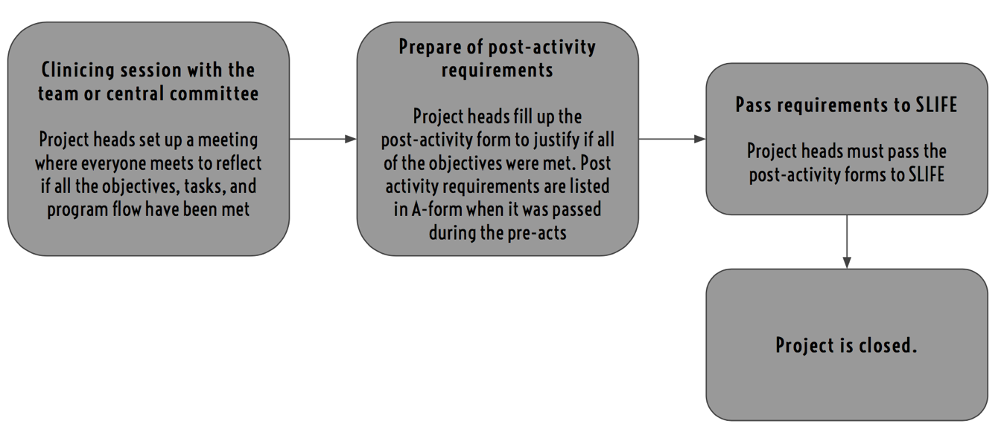

After the event proper is over, the project heads (with the help of fellow officers) then dismantle their materials, clean the venue, and account for all of the equipment borrowed. Then they have their clinicing session to reflect on the fine details of the project as well as the project itself. This must be preferably done after the event so that the problems encountered are fresh from the memory of the project heads. After taking note of what went wrong and the solutions they did to fix the problem, they now prepare the post-activity requirements. The project heads must fill up a post-activity form to justify if all of objectives they have set were all met. After careful deliberation, they now finalize the post-activity requirements and pass them to SLIFE. After that, the project is now officially closed.

**2.2 Data Requirements**

**A.** **Software Features**

● Calendar of Activities Management

○ A facility where the **CSG secretary** can **Add, Edit or Delete** projects. Inputs from the Calendar of Activities are translated to a **Project Page** when a **Project** **head** has been assigned by the **Committee Head** of the committee assigned under the Calendar of Activities.

○ The following data are required when adding a project: **Nature of Activity, Type of Activity, Goal, Objectives, Title, Description, Measure, Date, Committee-in-Charge and Status**. The **Project Head** can be left empty when project is initially created.

○ This is also where the **Committee Head** of the committee-in-charge of a project **assigns** an executive under his committee as the **project head.**

● Notifications Management

○ **Everyone concerned** will be notified on the **changes** in the **Calendar of Activities**. **Officers** are notified on the **deadlines** for the paperworks of the project they are currently handling and if they have been **assigned** as a Project head in the Calendar of Activities. **Committee** **heads** are notified if their committee has been **placed** under a **project**. The **president** is notified on **every change** in the **Calendar of Activities** and on **every update** on **all projects and their corresponding paperworks**. The **CSG secretary** will be notified when there are **changes** to the **Calendar of Activities** that is not theirs. **Publicity head** will be notified when a project has **all** of their pre-activity paperworks have been tagged as **approved.**

● Template Repository

○ A facility where the **templates** for **all** the documents are **placed** and all **officers** can **access**. The President can **upload** and **remove** templates.

● Project Management

○ A facility where the project heads can see the **overview** of the project they are currently handling. It has a **checklist** of **pre-activity requirements** which is **generated** by the **system**, based on the type of activity, where the project head can **update** the status of a paperwork with **Preparing, Processing, Approved, Pending** or **Disapproved**. It also has checklist of the activity proper, with the **venue, time, attendees** and **objectives**, which comes from the objectives stated in the Calendar of Activities. The **checklist** of **post-activity requirements** are user inputs because the requirements will come from the A-form that is passed during the pre-activity requirements. The Project head can **add** more items in each checklist if needed.

○ The CSG President can **access** and **view** all projects, **on-going** and **done** and can be filtered by **status** and **date** when needed.

● Committee Management

○ The facility where **committee heads** can view the **current** **workload** of each executive under his committee. Workload pertains if the said executive is handing a project/s.

● Account Management

○ Users of the system can **register** an account that has to be **verified** by the CSG president.

○ Users, when they already have an account, can change their **password**.

○ The CSG president **sets** their **committee** and **position** upon verification of their account.

**B.** **Database Design**

● *User Accounts -* The User Accounts table stores the data of each registered user in the system. All fields cannot be null, except for committee. Upon creation, however, fields position and committee can be null.

○ **UserID** - primary key, unique and not null

○ **Username** - DLSU email which serves as the username, must be unique

○ **Password** - Login verification, must have numbers and letters. Minimum of 8 and maximum of 20 characters

○ **FirstName** - Maximum of 15 characters

○ **LastName** - Maximum of 15 characters

○ **Position** - Position held in CSG, default ‘tba’

○ **Committee** - Committee user is part of in CSG, default ‘tba’

○ **Workload** - Number of projects assigned to the user, default value 0

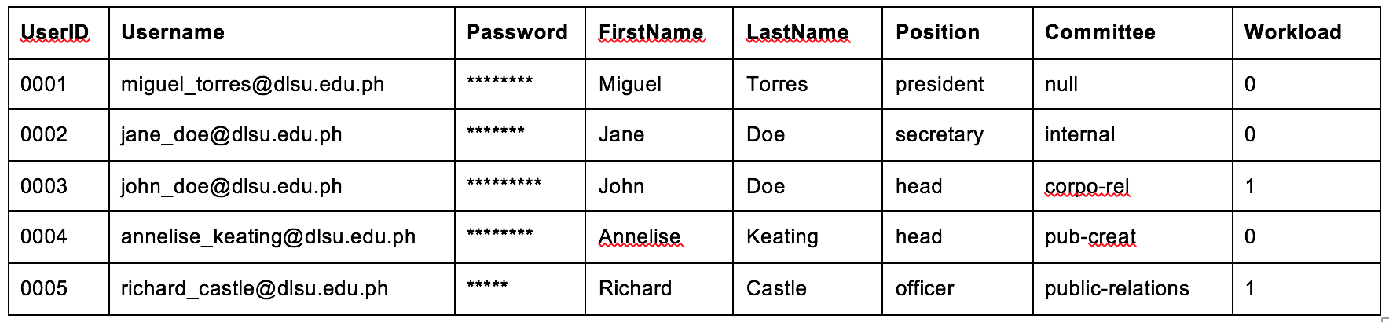

● *Project -* The project table stores the data of each project entered by the CSG secretary. This data populates the Calendar of Activities in the system. Upon creation, project head column is the only one that can be null.

○ **ProjectID** - primary key, unique and not null

○ **NatureofAct** - specifies the nature of Activity, max 30 characters

○ **TypeofAct** - specifies the type of Activity, max 30 characters

○ **Goal** - goal of the project, max 200 characters

○ **Objectives** - objectives of the project, max 300 characters

○ **Title** - Title of Activity

○ **Description** - brief description of activity, max 300 characters

○ **Measure** - expected number of participants

○ **Date** - Date of the project to be held on

○ **CommInCharge** - Specifies the committee in charge, max 15 characters

○ **Status** - ‘on-going’ or ’done’ status of the project

○ **ProjectHead** - userID of the assigned officer in charge

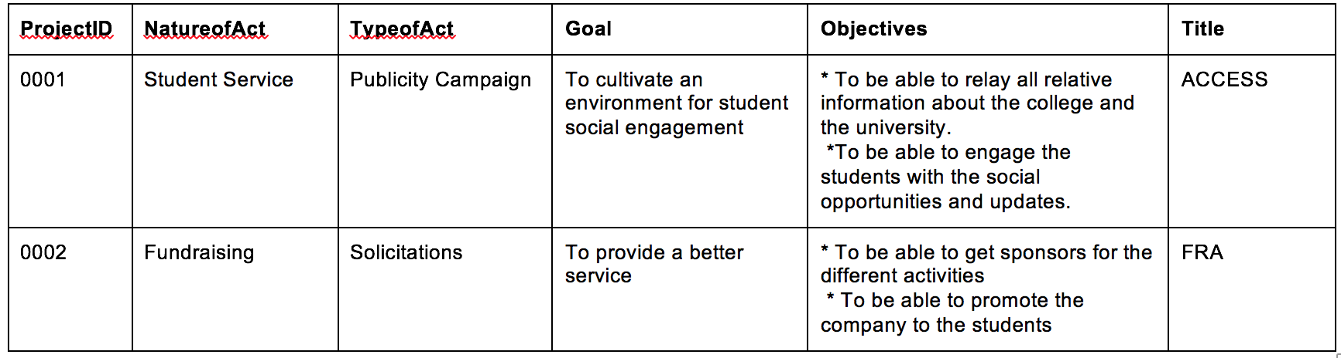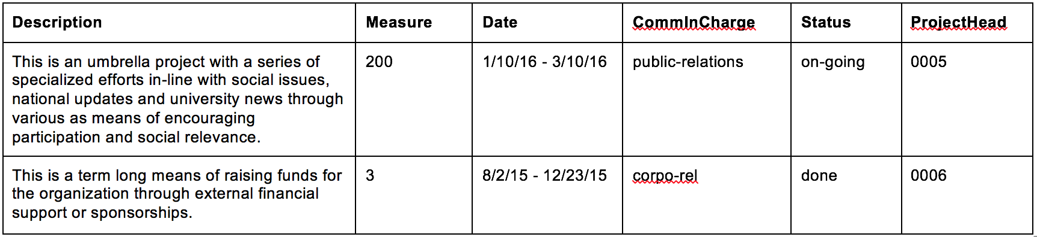

● *Paperwork -* The paperwork table stores the relevant information per document in the project. No fields can be null except for DateDue when document is processed and done.

○ **PaperID** - primary key, unique

○ **ProjectID** - foreign key that links to project table

○ **DocType** - type of document, 50 characters max

○ **Status** - status of the paperwork marked as ‘preparing’, ‘processing’, ‘accepted’, ‘pended’ and ‘rejected’

○ **DateDue** - date of when said paperwork should be done

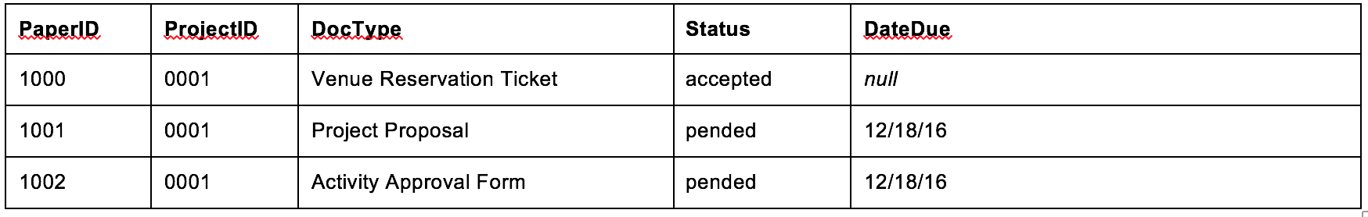

● *Notification -* The notification table stores the information regarding each notification an officer gets. No fields can be null.

○ **NotifID** - primary key, unique

○ **UserID** - foreign key, links to the user accounts table

○ **Time** - time frequency of when notification should next come up, in hours

○ **Message** - the message in the notification which is generated by the system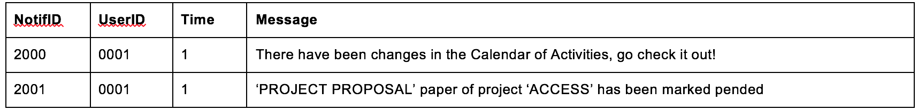

**C.** **Reports**

● *Activity Log*

This report is used to generate the list of activity made by all of the users in the system. It is arranged by timestamp.

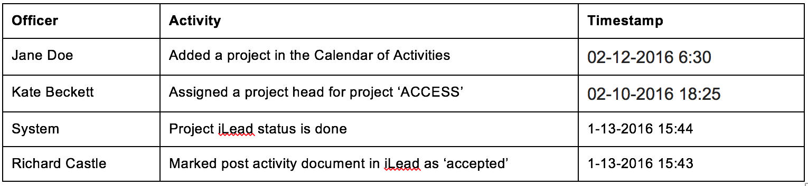

● *List of Registered Users*

This report is used to generate the list of users in the system. It is arranged by position held in the organization.

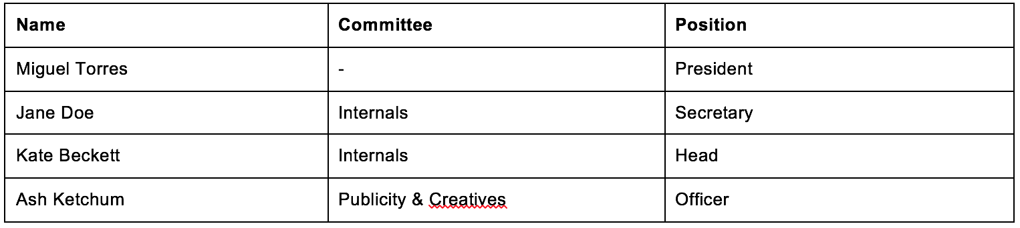

**2.3 Roles in the Business Process**

|  |  |
| --- | --- |
| **Role** | **Description of Tasks** |
| President | - Determine a problem that is prevalent in the college  - Propose a solution to the problem  - Prepares the GOSM at the start of the term  - Inform secretary of projects in the GOSM  - Monitors the projects and his officers |
| Secretary | - Fills up the Calendar of activities based on the GOSM  - Notify officers of the changes in the calendar of activities |
| Project Head | - Updates project status  - Reserve venues  - Accomplishes necessary documents needed for project  - Monitor the fine details of an event  - Handles the clinicing session after a project  - Prepare and processes post-activity requirements  - Informs president of statuses of paper works and projects |
| Committee Head | - Assign project heads |

**3 Problem Analysis**

|  |  |  |  |
| --- | --- | --- | --- |
| **Description** | **Cause** | **Symptoms** | **Impact** |
| Difficulty to monitor projects | - No automated process for project management, only the president’s planner | - Officers can’t inform and update everyone about the current status of the project because of their schedules. | - Due to mismanagement of the projects, they may be cancelled or end up as failures. |
| Difficulty to manage the paperwork | - DAAM’s paperwork notification is currently under construction  - Officers do not have copies of all of the document templates | - There are cases in which some documents are missing.  - Officers have to ask other officers where they can look for the template of the document they need to process. | - Delays in preparing paperwork and processing, which may delay the activity. |
| Disorganization in preparing paperworks | - No checklist that specifies the papers to be processed and completed  - Officers do not have copies of all the document templates | - Project heads clarifying which additional paperworks to pass, when activity is different.  - Paperworks are either denied or pended by the office because of incomplete requirements.  - Officers asking for the templates of documents needed for the project | - Deduction of points of the organization  - Paperwork are processed late therefore it can delay the event. |
| Late submission of pre-activity requirements | - Paperworks are not processed early and did not give allowance for pending or rejected papers  - There are different requirements for different types of activity and the project heads are not very familiar on the paperworks they needed. | - President goes to consultation with the offices to justify lateness  - The president reminds officers to submit paperworks on time | - Activities could get cancelled or moved to another day  - Speakers, may not be informed of the changes on the event / talk |
| Late submission of post-activity requirements | - Project heads sometimes pass the work to the documentations committee | - President reminds project heads that they need to submit post-activity requirements | - Deduction of points for the organization  - Organization may have a negative standing because of the last submission of paperworks |

**4 Software Solution**

**4.1 Objectives**

The Computer Studies Government Project Management System (CSG-PMS) aims to ease the difficulty of managing and monitoring of projects and activities within the college.

● To provide a facility for organizing days for the paperwork deadlines and project execution;

● To provide a facility for monitoring the status of the required paperwork;

● To provide a facility for tracking of the necessary paperwork for a project;

● To notify the users regarding updates and changes in a project;

● To provide a facility where templates for paperworks can be downloaded;

● To provide a facility where the CSG secretary can input upcoming projects and automatically notify officers;

● To provide a checklist for the necessary paperworks needed based on type of activity;

● To provide a checklist during the activity proper based on the objectives states in the pre-activity proposal

**4.2 Characteristics**

The application must be **easily accessible** to all of the organization’s officers. It must be available with them on the go (it must run also on a mobile device) so that they may be notified once they start up the application.

The software data must be **dynamic** in a sense that the data that they can update is limited on the officer’s position. It must enable the CSG president to update the roster of planned activities, assign project heads, and update project statuses. Also, it must enable the committee heads to assign a project head within his/her pool of officers to a particular project and to be able to update their project status. Finally, it must enable the officers to update the status of their projects.

The application must also be **secure** that it can only be used by the organization’s officers. There should be a mechanism that authenticates a user if they are part of the organization or not.

The application must also be **efficient** since the system should be usable in any device, the user interface (UI) must be responsive.

The application must also be **easy to use** to avoid any complications that may arise in the usage of the application.

**5 User Stories**

**5.1**

|  |  |
| --- | --- |
| **User Story #1:** The users must be able to access their accounts to benefit from the system | |
| **Estimate (Days):** 2 days | **Priority: 10** |
| **Pre-condition:** The president and officers must already have a registered account. | |
| **Scenario:**  1. The president or officers will be asked by the system to enter his/her username and password.  2. Users input their username and password.  3. The system validates the entered data.  4. The system displays their specific dashboard. | |
| **Post-condition:** The president or officer is logged in. | |
| **Acceptance Criteria:**  - Verify that the dashboard will include:  a) news feed/ initial notifications  b) system navigation  c) name of logged in user  - Verify that the username and the password are correct, the main menu will show up.  - Verify that the username and or password is incorrect or does not exist, the dashboard will not show up and the user will be prompted for the correct username and password.  - Verify that the officer is not registered, the system will display a message informing the user to register an account, which will be accepted or validated by the President. | |

**5.2**

|  |  |
| --- | --- |
| **User Story #2:** As an officer of the CSG, I want to be able to register an account so I could use the system. | |
| **Estimate (Days):** 1.5 days | **Priority: 10** |
| **Pre-condition:** The officer must not have an account in the system yet. | |
| **Scenario:**  1. The system will ask the user for their details.  2. User submits information to the system and waits for the validation by the President. | |
| **Post-condition:**  - The user still has to wait for his registration to be validated before using the system.  - The system notifies the president through e-mail regarding a new registration. | |
| **Acceptance Criteria:**  - Verify that the system asked the following details from the user**:**  a. DLSU email, which will serve as their username  b. ID number  c. Password  d. Confirm password  e. First Name  f. Last Name  g. Contact number  - Verify that the CSG president is notified through email regarding an officer registering.  - Verify that the e-mail has been sent, and the system would show whether or not the e-mail has been successfully sent or not  - Verify that the system must be able to accept the registration and will forward it to the CSG President for validation and activation. | |

**5.3**

|  |  |
| --- | --- |
| **User Story #3:** As the CSG president, I want to be able to accept officers registering into the system so that they can benefit from it as well. | |
| **Estimate (Days):** 1.5 days | **Priority: 10** |
| **Pre-condition:**  - The CSG president must be logged on into his account.  - An officer has registered for an account.  - The CSG president must be notified through e-mail. | |
| **Scenario:**  1. The system will notify the president about the officers trying to register for an account.  2. The president will then be given two options, to either accept or decline the registering officer.  3. If the CSG president accepted the registration, he will then be asked by the system as to what committee the registering officer is part of.  4. If the CSG president declined, the account will not be part of the database. | |
| **Post-condition:** The registering officer has his account validated by the president and can now use the system. | |
| **Acceptance Criteria:**  - Verify that only the CSG president can validate a registration to the system  - Verify that the accepted officer can log in and use the system.  - Verify that President can assign committee and position when validating a user.  - Verify that the database gets updated when registration has been validated.  - Verify that the database is not changed when registration has been declined. | |

**5.4**

|  |  |
| --- | --- |
| **User Story #4:** As CSG president, I want to be informed on the status of the post-activity and pre-activity requirements when they have been prepared and submitted to the office so that I can be assured that projects are done. | |
| **Estimate (Days):** 2.5 days | **Priority: 20** |
| **Pre-condition:**  - CSG President needs to be logged in on the system | |
| **Scenario:**  1) The CSG president should go to the lists of activities, and he would be able to access “pre-activity status”, “ready for implementation”, and “post activity status”.  2) The system will show a list of activity requirements, and a quantitative progress which shows how complete the activity is.  3) The system would show all information regarding that activity with its corresponding status with each paper work.  4) System can also show activities done in the past when needed by the president. | |
| **Post-condition:** | |
| **Acceptance Criteria:**  - Verify that the system would redirect the CSG president somewhere with three options namely:  a) Pre-Activities status  b) Ready for implementation  c) Post-Activities status  - Verify that the system should present the lists of currently ongoing activities ordered by alphabet, with the information:  a) Activity Name  b) Activity Type  c) Activity Status  - Verify that the CSG president should be able to access the activity information which would include:  a) Progress and checklist of the activity requirements.  b) Information of the activity.  - Verify that the activity status can be updated by the project heads.  - Verify that the system would show the latest status of the project. | |

**5.5**

|  |  |
| --- | --- |
| **User Story #5:** As the CSG President I want to upload document templates so that the project heads will be prepared for their papers. | |
| **Estimate (Days):** 2 days | **Priority: 20** |
| **Pre-condition:** The CSG President is logged in on the system. | |
| **Scenario:**  1. The CSG President should be able to access all the document templates.  2. The system will display the files in a list format when the documents are accessed.  3. The CSG President would be able to check if the document templates are uploaded.  4. The system would show all the documents currently uploaded in a list; the system would also give an option for the CSG president to upload document templates  5. The CSG President would be able to upload new document templates in the system. | |
| **Post-condition:** The system reflects the uploaded document templates. All members of the CSG can view the document templates. | |
| **Acceptance Criteria:**  - Verify that the files would be up to displayed in a list format of all documents.  - Verify that the documents have the following information:  a) Document name  b) Date uploaded  c) Version number  - Verify that the uploaded document templates are in the system’s repository.  - Verify that the uploaded document cannot be deleted/modified by other members of the organization apart from the CSG President. | |

**5.6**

|  |  |
| --- | --- |
| **User Story #6:** As the project head, I want to have a list of pre-activity requirements for the project based on the project type stated in the calendar of activities so that I will be prepared and avoid pending papers. | |
| **Estimate (Days):** 2.5 days | **Priority: 20** |
| **Pre-condition:** The project head is logged in on the system.  The project exists in the database. | |
| **Scenario:**  1. The project head opens the list of projects he/she is handling.  2. The system displays the list of projects.  3. The project head selects the project he/she wants to see.  4. The system displays the project’s page.  5. The project head opens the list of pre-activity requirements of the project. | |
| **Post-condition:** The system displays the information regarding the project and the pre-activity requirements. | |
| **Acceptance Criteria:**  - Verify that the system displays the list of projects, each with the following information:  a. Project name  b. Project head in charge  - Verify that the system displays the project selected by the project head.  - Verify that the system displays the following information regarding the selected project’s page:  a. Project title  b. Goals  c. Objectives  d. Strategy  e. Measure  f. Date  g. Time  h. Venue  i. Project head  j. Committee members  - Verify that the system displays the the list of pre-activity requirements, each with the following information:  a. Document name  b. Status of the document: Prepared/Processed/Accepted/Pended/Rejected  c. Deadline | |

**5.7**

|  |  |
| --- | --- |
| **User Story #7:** As the project head, I want to have access on the checklist of the requirements during the event so that I can monitor the activity during its execution. | |
| **Estimate (Days):** 2 days | **Priority: 30** |
| **Pre-condition:** The project head is logged in on the system.  The project exists in the database. | |
| **Scenario:**  1. The project head selects the project he/she wants to open from the list of projects he/she is handling.  2. The system displays the selected project’s page.  3. The project head opens the checklist of requirements during the event.  4. The system displays the checklist of requirements during the event.  5. The project head checks the checkbox of the item he/she has checked. | |
| **Post-condition:** The system reflects the changes made in the database.  The system notifies the CSG president regarding the updates on the project execution. | |
| **Acceptance Criteria:**  - Verify that the system displays the list of projects, each with the following information:  a. Project name  b. Project head in charge  - Verify that the system displays the following information regarding the selected project’s page:  a. Project title  b. Goals  c. Objectives  d. Strategy  e. Measure  f. Date  g. Time  h. Venue  i. Project head  j. Committee members  - Verify that system displays the checklist of requirements during the event with the following items:  a. Venue  b. Program flow  c. Participants  d. Materials  - Verify that the database is updated when the project head made some changes.  - Verify that the system will automatically notify the CSG president in the system regarding the updates on the project execution. | |

**5.8**

|  |  |
| --- | --- |
| **User Story #8:** As project head, I want to access and download the document templates when I need them so that I can prepare the required paperwork. | |
| **Estimate (Days):** 8 days | **Priority: 20** |
| **Pre-condition:** The project head is logged in on the system.  The document templates exist in the database. | |
| **Scenario:**  1. The project head opens the list of document templates, enumerated based on the type of activity stated in the calendar of activities for the particular project.  2. The system displays the list of document templates available.  3. The project head selects the document template he/she wants to open.  4. The system displays the selected document template.  5. The project head downloads the document template. | |
| **Post-condition:** The project head downloads the document template and save it in a local folder. | |
| **Acceptance Criteria:**  - Verify that the system displays the complete list of document templates. (Please refer to Appendix D for the list of required documents based on the nature of activity)  - Verify that the system displays the selected document template. (Please refer to Appendix C for sample document templates)  - Verify that the project head has access to the document templates.  - Verify that the project head can download the document templates. | |

**5.9**

|  |  |
| --- | --- |
| **User Story #9:** As the project head, I want to inform the CSG President on the status of the project requirements so that it will be easier for both the president and I to update each other. | |
| **Estimate (Days):** 1.5 days | **Priority: 30** |
| **Pre-condition:** The project head is logged in on the system.  The project exists on the network. | |
| **Scenario:**  1. The project head selects the project he/she wants to open from the list of projects he/she is handling.  2. The system displays the selected project’s page.  3. The project head opens the list of project requirements.  4. The system displays the list of project requirements.  5. The project head changes the status of the requirement he/she wants to change.  6. The project head saves the changes he/she made. | |
| **Post-condition:** The system updates the database.  The system notifies the CSG president regarding the changes. | |
| **Acceptance Criteria:**  - Verify that the system displays the list of projects, each with the following information:  a. Project name  b. Project head in charge  - Verify that the system displays the following information regarding the selected project’s page:  a. Project title  b. Goals  c. Objectives  d. Strategy  e. Measure  f. Date  g. Time  h. Venue  i. Project head  j. Committee members  - Verify that the system displays the list of project requirements (Please refer to Appendix D), each with the following information:  a. Document name  b. Status of the requirement: Prepared/Processed/Approved/Pended/Rejected  c. Deadline  - Verify that the project head is allowed to make some changes on the status of the requirements.  - Verify that the database is updated when the project head made some changes.  - Verify that the system will automatically notify the CSG president in the system regarding the changes. | |

**5.10**

|  |  |
| --- | --- |
| **User Story #10:** As the project head, I want to be reminded of the deadlines for the processing of paperworks so that it will not slip off my mind. | |
| **Estimate (Days):** 3 days | **Priority: 30** |
| **Pre-condition:** The project head is logged in on the system. | |
| **Scenario:**  1. The system displays the list of ongoing projects.  2. The system displays a notification on when the paperwork is due for a specific project. | |
| **Post-condition:** The system removes the notification once the paperwork has already been processed and its status is accepted. | |
| **Acceptance Criteria:**  - Verify that the system displays the list of projects , each with the following information:  a. Project name  b. Project/Event date  c. Project/Event time  - Verify that the system displays the following information about the requirement:  a. Document name  b. Project name  c. Status of the document: Prepared/Processed/Approved/Pended/Rejected  d. Deadline  - Verify that the notification displays the number of days left before the deadline.  - Verify that the accepted documents are no longer displayed. | |

**5.11**

|  |  |
| --- | --- |
| **User Story #11:** As the project head, I want to have a list of post-activity requirements so that I will be able to keep track of the documents that I have to submit after completion of the event. | |
| **Estimate (Days):** 2.5 days | **Priority: 30** |
| **Pre-condition:** The project head is logged in on the system.  The project exists in the database. | |
| **Scenario:**  1. The project head opens the list of projects he/she is handling.  2. The system displays the list of projects.  3. The project head selects the project he/she wants to see.  4. The system displays the project’s page.  5. The project head opens the list of post-activity requirements of the project.  6. The system displays the list of post-activity requirements.  7. The project head checks the checkbox of the document that has been submitted. | |
| **Post-condition:** The system reflects the changes in the database.  The system notifies the CSG president regarding any updates on the requirements. | |
| **Acceptance Criteria:**  - Verify that the system displays the list of projects, each with the following information:  c. Project name  d. Project head in charge  - Verify that the system displays the project selected by the project head.  - Verify that the system displays the following information regarding the selected project’s page:  k. Project title  l. Goals  m. Objectives  n. Strategy  o. Measure  p. Date  q. Time  r. Venue  s. Project head  t. Committee members  - Verify that the system displays the the list of post-requirements, each with the following information:  d. Document name  e. Status of the document: Prepared/Processed/Accepted/Pended/Rejected  f. Deadline  - Verify that the project is already executed.  - Verify that the project head’s changes are reflected in the database.  - Verify that the system notifies the CSG president. | |

**5.12**

|  |  |
| --- | --- |
| **User Story #12:** As the Committee Head, I want to be informed if there is a project my committee needs to handle so that I can efficiently assign a project head. | |
| **Estimate (Days):** 2.5 days | **Priority: 10** |
| **Pre-condition:**  - The committee head is logged in on the system.  - The committee head has been notified through email | |
| **Scenario:**    1. The committee head would be able to view a new notification in the dashboard. .  2. The system would show a list of projects that are currently being handled by the committee.  3. The committee head would be able to pick a project.  4. The system would display the project details. | |
| **Post-condition:** The Committee Head is notified on the upcoming project under his/her committee. | |
| **Acceptance Criteria:**  - Verify that the dashboard can have up to five notifications at a time.  - Verify that the project details include:  a) Activity name  b) Activity status  c) Activity head  - Verify that the project details sent to the Committee Head is designated to his/her committee.  - Verify if the system was able to notify the Committee Head.  - Verify if the project details sent to him/her is correct.  - Verify that the project details to one Committee Head is not broadcasted to other Committee Heads and other officers. | |

**5.13**

|  |  |
| --- | --- |
| **User Story #13:** As the Committee Head, I want to see the workload of the officers under me. | |
| **Estimate (Days):** 2 days | **Priority: 30** |
| **Pre-condition:** Committee Head must be logged in to the system.  There should be an updated roster of the final set of officers that will be under him/her. | |
| **Scenario:**  1. The committee head is able to access the database with the officers and their respective workload.  2. The committee head would be able to view the list of officers.  3. The committee head can pick a specific officer.  4. The system would display the officer and his/her respective workload. | |
| **Post-condition:** The Committee Head is presented with the roster of officers under the committee head and their respective current workload. | |
| **Acceptance Criteria:**  - Verify that the database for officers will contain:  a) Officer name  b) Officer workload  c) List of currently assigned workload  d) Officer committee  - Verify that the system must be able to display the correct roster of officers under the Committee Head.  - Verify that the system must be able to display the updated workload of the officers under the Committee Head. | |

**5.14**

|  |  |
| --- | --- |
| **User Story #14:** As the Committee Head, I want to be able to assign a project to my executives so that they can be immediately notified of their task. | |
| **Estimate (Days):** 2.5 days | **Priority: 20** |
| **Pre-condition:**  - The Committee Head is notified of the project they should be handling from the calendar of activities.  - The Committee Head must be logged in the system. | |
| **Scenario:**  1. The system will present the details of the project based on the calendar of activities.  2. The committee head would be able to go to the “calendar of activities”.  3. The system would show the different activities that must be distributed. The Committee Head will be able to pick an activity.  4. The system would show the activity details.  5. The Committee Head would be able to assign an executive or themselves.  6. The system would show the current workload of the different officers.  7. The Committee Head submits the changes in the calendar of activities. | |
| **Post-condition:**  - The column in the calendar of activities that pertains to project head has been updated.  - The committee member would be notified through email when they are assigned a task. | |
| **Acceptance Criteria:**  - Verify that the project details will include:  a) Project title  b) Goals  c) Objectives  d) Strategy  e) Measure  f) Date  g) Time  h) Venue  - Verify that the “Officer workload” and the “List of currently assigned workload” of the assigned officer will be updated in the database.  - Verify that the assigned executive is notified of the project they will handle.  - Verify that the project is updated with a project head in the database. | |

**5.15**

|  |  |
| --- | --- |
| **User Story #15:** As the CSG secretary, I want to add the project details from the GOSM to the Calendar of Activities, where everyone, the president and officers, can see so that it will be easier and more accessible for everyone. | |
| **Estimate (Days):** 2 days | **Priority: 10** |
| **Pre-condition:** The CSG secretary is logged in on the system. | |
| **Scenario:**  1. The CSG secretary checks the Calendar of Activities inside the system.  2. The system displays the Calendar of Activities to the CSG Secretary.  3. The CSG secretary adds a project.  4. The system requires the CSG Secretary to provide important information about the project  5. The CSG secretary saves the project. | |
| **Post-condition:** The system adds the project in the Calendar of Activities database.  The system notifies the CSG president regarding the added project. | |
| **Acceptance Criteria:**  - Verify that the project is not yet existing in the Calendar of Activities database.  - Verify that the project is added in the Calendar of Activities database.  - Verify that the system prompted the CSG Secretary to provide the following:  - Title  - Nature of Activity  - Type of Activity  - Goal  - Objectives  - Title  - Description  - Measure  - Date  - Committee-in-Charge  - Status  - Project heads  - Venue  - Remarks  - Verify that the database contains the information provided by the CSG Secretary.  - Verify that the information provided is aligned with the expected data format for each input. | |

**5.16**

|  |  |
| --- | --- |
| **User Story #16:**  As CSG secretary, I want everyone, the president and officers, to get updates on the revisions and additions to the Calendar of activities, especially when it pertains to a committee so that they, the concerned officers, will know without me reminding them. | |
| **Estimate (Days):** 2 days | **Priority: 10** |
| **Pre-condition:** The CSG secretary is logged in on the system. | |
| **Scenario:**  1. The CSG secretary views the Calendar of Activities.  2. The system displays the Calendar of Activities.  3. The CSG secretary adds or updates a project.  4. The system requires the CSG Secretary to provide important information about the project.  5. The CSG secretary saves the project. | |
| **Post-condition:** The system adds the project in the Calendar of Activities database.  The system notifies the CSG president and the people concerned regarding the updated and or added project. | |
| **Acceptance Criteria:**  - Verify that the project is not yet existing in the Calendar of Activities database if the project is new.  - Verify that the project is added in the Calendar of Activities database if the project is new.  - Verify if the updated project is correctly updated in the Calendar of Activities database.  - Verify that the committee heads and officers concerned with the additional changes in the calendar of activities are notified.  - Verify that the president is notified on every additional projects and changes in the calendar of activities.  - Verify that the committee heads NOT concerned are not notified by the system.  - Verify that the system asked the CSG Secretary to provide the project details that consists of the following:  - Title  - Nature of Activity  - Type of Activity  - Goal  - Objectives  - Title  - Description  - Measure  - Date  - Committee-in-Charge  - Status  - Verify that the information provided is aligned with the expected data format for each input.  - Verify that the notified concerned officers consist of:   * President * Chief of Staff * Internal Officer * External Officer * Committee Heads concerned * Project Heads | |

**5.17**

|  |  |
| --- | --- |
| **User Story #17:** As the publicity head, I want to be informed when all the pre-activity requirements are approved so that I can start publicizing the activity. | |
| **Estimate (Days):** 2 days | **Priority: 30** |
| **Pre-condition:** The publicity head is logged in on the system.  The system notifies the publicity head of projects with all pre-activity requirements approved. | |
| **Scenario:**  1. The publicity head sees that he has a notification.  2. The publicity head checks the notification and sees the approved project. | |
| **Post-condition:** The system adds the project in the Calendar of Activities database.  The system notifies the CSG president regarding the added project. | |
| **Acceptance Criteria:**  - Verify that the user is the publicity head.  - Verify that all the pre-activity requirements of the project have been approved.  - Verify that the system automatically notified the publicity head regarding the approved project. | |

**5.18**

|  |  |
| --- | --- |
| **User Story #18:** As a user, I want to end my session by logging out of the system. | |
| **Estimate (Days):** 1.5 days | **Priority: 10** |
| **Pre-condition:** The users must be already logged in. | |
| **Scenario:**  1. The user chooses the option to logout of the system. | |
| **Post-condition:**  The user is logged out of the system. | |
| **Acceptance Criteria:**  - Verify that the user is not able to get back to the system after logging out.  - Verify that the user is not able to get back to the system after logging out by pressing the browser “back” button.  - Verify that the user cannot go back to the previous page if they logged out. They must log in once again. | |

**5.19**

|  |  |
| --- | --- |
| **User Story #19:** As the CSG secretary, I want to update the project details from the GOSM to the Calendar of Activities if there is a change in the project details so that everyone, the president and concerned officers, will be updated so that they will have the updated details to see. | |
| **Estimate (Days):** 2.5 days | **Priority: 10** |
| **Pre-condition:** The CSG secretary is logged in on the system. | |
| **Scenario:**  1. The CSG Secretary wants to see the Calendar of Activities.  2. The system displays the Calendar of Activities to the CSG Secretary.  3. The CSG secretary will select a project to be updated.  4. The system prompts the CSG Secretary to provide important information about the project.  5. The CSG secretary saves the project. | |
| **Post-condition:** The system updates the selected project in the Calendar of Activities database. | |
| **Acceptance Criteria:**  - Verify that the project is updated in the Calendar of Activities database.  - Verify that the system asked the CSG Secretary to provide the project details that consists of the following:  - Title  - Nature of Activity  - Type of Activity  - Goal  - Objectives  - Title  - Description  - Measure  - Date  - Committee-in-Charge  - Status  - Verify that the information provided is aligned with the expected data format for each input.  - Verify that the project was updated in the database containing the information provided by the CSG Secretary.  - Verify that the notified concerned officers consist of:   * President * Chief of Staff * Internal Officer * External Officer * Committee Heads concerned * Project Heads | |

**Appendix A - Improved Business Process**

With the help of the software solution implemented by the House of Megan, the developers hope that the business process of the CSG improves. The following images displays how software solution may be integrated with the current business process of the organization.

**A.** **Conceptualizing the Project**

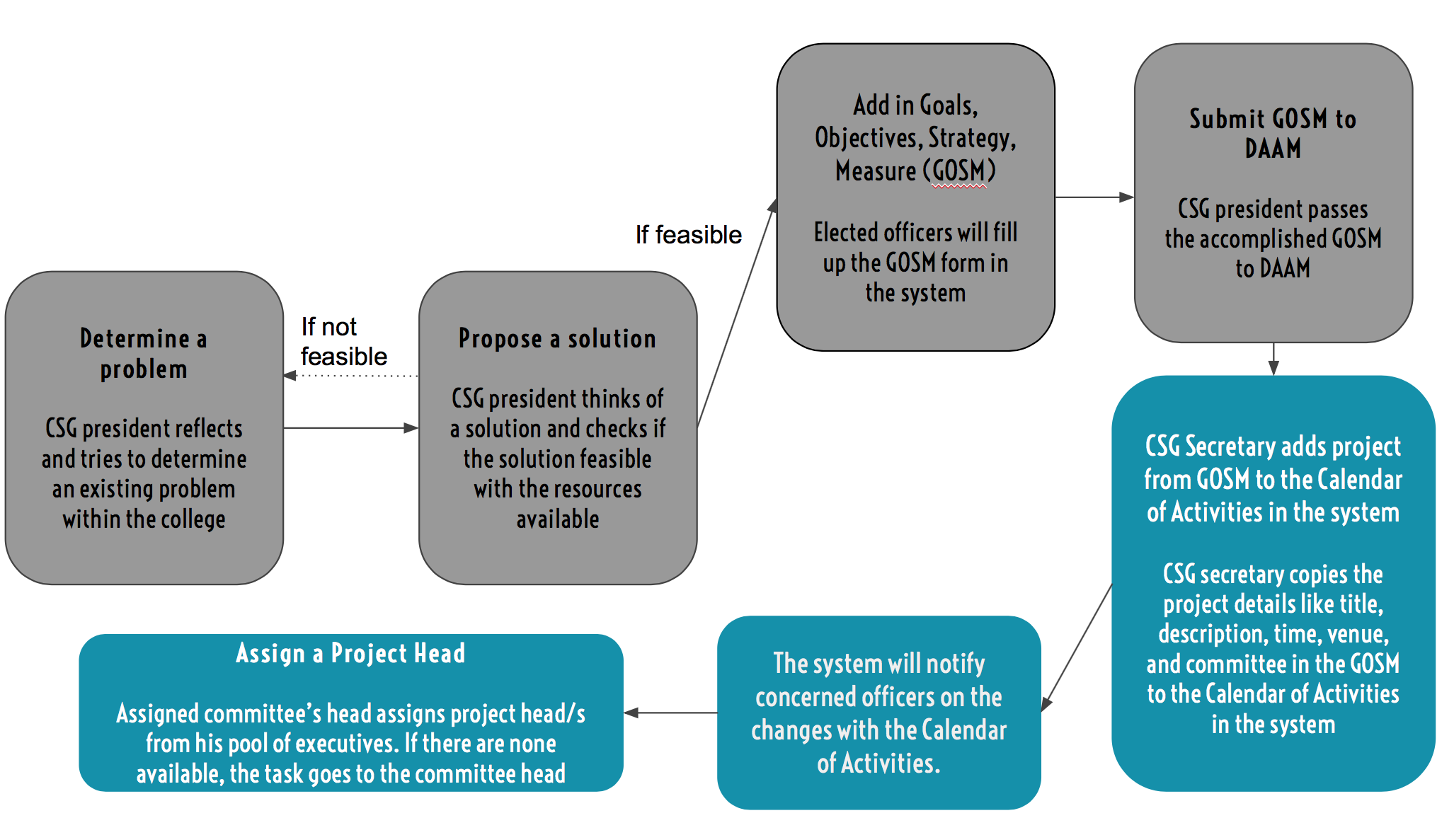

Similar to the current business process of the CSG, the CSG president still determines a problem and proposes a feasible solution to the problem. All the elected officers will fill up the GOSM (Goals, Objectives, Strategy, Measure) form in the system. The accomplished GOSM form will then be passed by the CSG president to the Department of Activity Approval and Monitoring (DAAM). Then, the CSG secretary will file the project details from the GOSM to the Calendar of Activities in the system. The system will automatically notify the concerned officers regarding the changes in the Calendar of Activities. Once they’ve all received the notification, they can then assign project heads for the activity.

**B.** **Before the Event Execution**

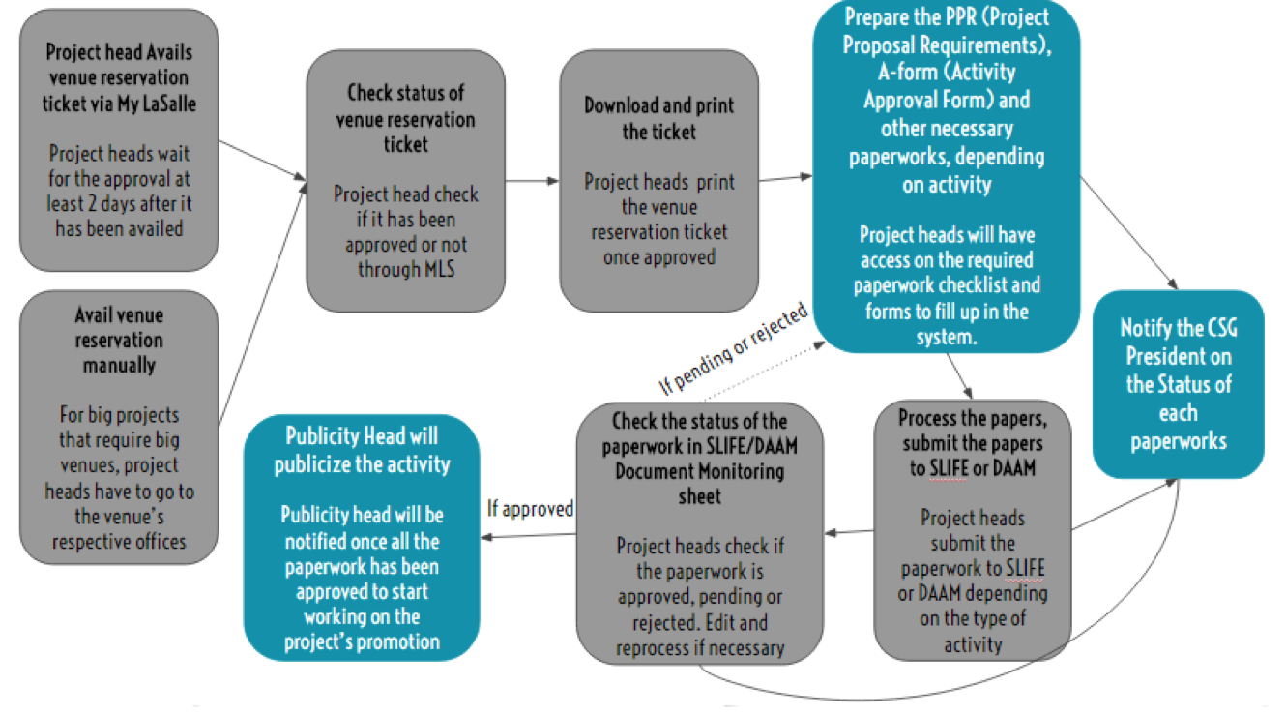

Before the execution of the event, project heads will still avail a Venue Reservation Ticket (VRT) via My LaSalle. They have to wait at least 2 days after the transaction before checking for the VRT’s status. Once the VRT has been approved, the project heads must print it and they may start preparing for the pre-activity requirements. The project heads will have an access on the required paperwork checklist and the forms needed to be filled up in the system. Once the required papers have been accomplished, the project heads may submit them to SLIFE or DAAM, depending on the type of activity. The project heads can check for the status of the paperwork in SLIFE/DAAM Document Monitoring google sheet. The system will send updates to the CSG president regarding the whole process of the pre-activity requirements. It will automatically inform the CSG president when a document has been prepared and is currently being processed by SLIFE or DAAM. It will also notify the CSG president once the status of the paperwork is updated. When all the pre-activity requirements have been approved, the system will automatically notify the publicity head so he/she will be able to start publicizing the activity.

**C.** **During the Event**

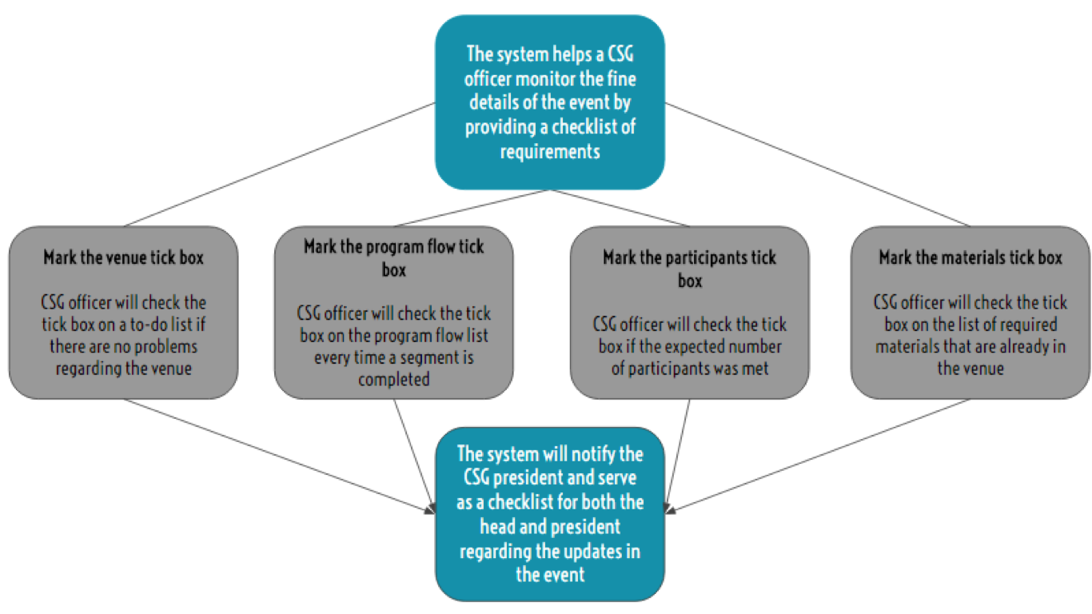

During the event, CSG officers will have an access to the checklist of requirements in the activity. The checklist will consist of the venue, program flow, participants, and materials. The system will automatically notify the CSG president on the updates of the event.

**D.** **After the Event**

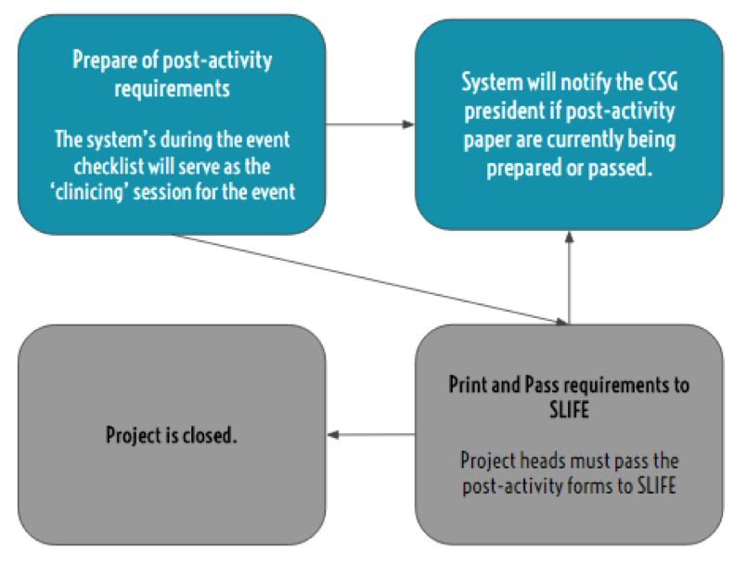

In the improved business process, the project head and the committee will no longer have to conduct a clinicing session wherein they evaluate the success of the event. The system’s during the event checklist will serve as the ‘clinicing’ session for the event. Therefore the project heads can start preparing the post-activity requirements as soon as the event is done. The system will automatically notify the CSG president regarding the updates on the post-activity requirements. Once the project heads have accomplished the paperwork, they will print and pass them to SLIFE. Finally, the project is closed.

**Appendix B - Interview Transcript**

**Initial Interview with the CSG President**

M - Miguel Torres, CSG President

I - Interviewers

**I**: Ok, Good afternoon I am Margaret Avancena and this is my teammate, Kenywil. First of all, we would like to thank you for letting us have this time to conduct this interview. Are you ready?

**M**: Yes.

**I**: How long have you been in the student government?

**M**: I’ve been active in the student government ever since I was a freshman in the college. This is my 4th year in the student government.

**I:** Nice, yes president! How’s it being the president, is it stressful?

**M:** Medyo, yeah, there’s a lot to think about.

**I:** Can you describe what you do for the CSG?

**M:** So basically, I was elected a CSG President, college president. Halos lahat ng processes kailangan ko imonitor. There are different departments under the organization. Internals, Externals, University Affairs, Admin Affairs, and the different committees under it. I basically have to monitor all the processes if they are still active and to make sure if all the projects are implemented well. Also, my basic role as CSG president is juggling my task, internally and externally of the college [affairs], I also have to represent the college and voice out concerns in the different sectors of the university. What makes it difficult is that I have to do that and at the same time monitor the internal processes of the college.

**I:** Ah, so it’s difficult to monitor-

**M:** Yes, especially when the officers have their own schedules that can’t match.

**I:** Can you describe us the process of project making? to the point of coming up of the with the idea and to the end of the activity?

**M:** Coming up with the idea, syempre you can’t make projects na “bara-bara” lang just for the college. You have to determine what’s it for, what’s the purpose of the activity and how is it relevant to the students, how are they going to benefit from it. So basically, me, the easy way to determine what my project’s going to be, I determine muna a problem. A specific problem that we target on in the college. For example, a projects as simple as this, it’s called “Hello from the Andrew side”. What’s the problem there? Students have the hassle of parang, they can’t contact the administration as easy as it was before. Since they transferred already to andrew and how are we going to contact them from gox? So syempre, kailangan kang umakyat dun, diba? So “Hello from the Andrew side” is an installation of telephone systems, here in gox. So yun, that’s how I determined it. One, the problem, then propose a solution. Then after proposing a solution, check if it is feasible with the available resources you have. For example, are there any offices willing to provide a set of telephones? Yes, physical facilities office. After that, determine the details of the project. Program flow, date of installation, basics naman yung project details, yung venue, date, details like how are you going to manage the project, time, and other needs. Other needs, depends on the type of project. This one, it’s a special case project because it is not a regular event that people really go to, it is something they really need in the college. It depends talaga, that’s why we have the student’s activity manual. I’ll give you a copy of it, maybe tomorrow?

**I:** Okay!

**M:** To continue, the processes naman, let’s say you have the basic ideas you want for the project, you have this concept, you have a nutshell of what your project is going to be. Syempre, in processing an activity, you have to have this, the “PPR”, Pre-activity requirements. It’s composed of, mainly, the A-form or activity form, the project in a bird’s eye view. Next is the Project proposal form “PPR”, and the venue reservation ticket, where your project is going to be. Those are the three main components of the activity requirements but it may also depend on the type of activity. Let’s say it’s a sponsorship activity, kailangan mo din ng Memorandum of Agreement.

**I:** But does it require the same basic requirements even if it's a different type of activity?

**M:** Yes, for all activities, the all need the Venue reservation ticket, PPR and A-form. Standard yung tatlong yun, but for every other activity, depending on the type, there may be more requirements to add on. Like, MOA, Memorandum of Agreement, if sponsorship. If it is a sports fest, you need waivers - notarized waivers. If it’s ticket selling, you need to have the design of the tickets and the price quotation.

**I:** Is there a form for those?

**M:** Yes, all of them, they all have a template. Another example is talks, you need to have the credential of the speakers. Basically, it depends, you can look it up on the students activity manual. But the 3 basic needs for the pre-activity requirements is the a-from, the project proposal form and the venue reservation ticket.

**I:** How about the processing of the papers?

**M:** So step by step, first you have to avail of the venue reservation ticket. You can get this by process this through My LaSalle. It could get approved in 2 days. After availing for the venue, after 2 days, you have to check if it is approved. If it is approved, download and print the ticket. Once you have the venue reservation ticket, that’s the only time you can process the PPR and the A-form. After those, you process those papers through S-LIFE or DAAM, depends on the nature of activity. Makikita mo naman sa A-form, type of activity. If it’s an academic contest, general assembly, etc all the activities that fall under this should be processed by DAAM, for the CSG. For CSO, it’s CSO. In our case, it’s DAAM, their activity monitoring team. For the activities that involve external relations, or external partnerships, like selling, donation drives, conferences, off-campus activities, they have to be processed through S-LIFE. Why S-LIFE? They have this legal processing that if something goes wrong, we will still be liable, but they will help us with it. It’s also one of the reasons why the waivers right now needs to be notarized.

**I:** Has it always been like that? That it needs to be notarized?

**M:** No, it’s a new process since the legal management team added it just to have a second check. After processing the papers, you have the activity itself. Once the event is already being done, the office or the project head has to monitor everything. Is the venue ok? Is the food ok?, if the activity has food. Was the program flow being followed? The program flow can be seen here, in the activity requirements. After the event, it is the responsibility of the project head to have a clinicing session with his team or his cencomm. That is where you catch up, if all the objectives, tasks, program flow, have been met. For example, the General Assembly, it says here in the program flow that there are 3 performers. You reflect is there were actually 3 performers. Were the expected number of participants reached? That’s how you reflect if the activity is successful. After that, you have to make the post-activity requirements. You fill up the post-activity form and that's where you can justify if all the objectives were met. That’s why it is important for the project head to make the clinicing session because that is how he’ll be able to answer the post-acts. After that, you have to pass it on to S-LIFE. That is when the entire account or project is closed.

**I:** How long usually processing ng projects?

**M:** For the venue processing, it takes at least 2 days. PPR, in processing the pre-activity requirements, diba you have the a-form and ppr, you pass it on to S-LIFE. S-LIFE takes about 3 days.

**I:** Do they notify you if na approve na nila or not?

**M:** No, you have to go there. That’s why it’s also hard monitoring the projects. But assumingly, dapat after 3 days, tapos na.

**I:** Are there times that it goes over 3 days?

**M:** Yes, depending if there is a holiday or if the director of activities is on leave. After that, all the paperworks must be done 3 days before the event itself. But in CSG, I give them a standard that 1 week before, everything must be settled, paperworks and all. Then the activity proper, depends on the project head and how long the event will last. After that post-activity requirements. In the A-form, there will be a due date. For example, you submit it on Jan 19. Usually, they give you a month long range before you can process the post-activity. Kunyari you process it January 22, you can process the post-acts until Feb 22. Month long. You can prepare it as early as the event is done. That’s it.

**I:** Are there times na hindi na fufulfill yung post-acts?

**M:** Yes, what happens is, you assign a project head, then what usually happens, I find it funny, that they generalize the task of documentations team that they will process the post-acts. Apparently, the task there is that, you’re a project head, you start the activity, you also end the activity. Once you process the pre-activity of the project, after the project, you will also be the one to process the post-acts. The documentations team’s assignment is to assure that everything or all the documents for the project is processed or is going smooth.

**I:** Are there also times na yung pre-acts naman hindi nasesettle, 1 week before the activity?

**M:** Yes, there are time, for example, hindi naapprove si venue reservation ticket, so you have to look for another venue, or you have to justify to the PFO why the venue was not approved and because of that, madedelay yung time mo. Let’s say your activity is already, Let’s say today is Monday and your activity is on Friday, if you got your pre-acts, you plan to pass your pre-acts on Monday, sakto lang, Tuesday, Wednesday, Thursday, before Friday. But then, let’s say you got delayed, hindi siya naapprove, so it takes another two days but that’s already 2 days before the activity. So what happens is that, there will be many consultations to be made. You have to go to the department and justify why you are passing the pre-acts requirements late. But basically, dapat talaga 3 days, it has always been a standard that 3 days before the activity itself.

**I:** Are there times na activities are not pushed through because of the papers?

**M:** Yes, let’s say you tried to consult the office for passing it late, sometimes, there are times that they become so strict that they will not allow the activity, because that’s the standard talaga. If it doesn’t push through, wala talaga.

**I:** In your 4 years of experience in the students government, what is the worst case scenario from what you remember?

**M:** Worst case scenario is that, we had a company talk at LSCS, all the pre-acts, okay na, venue reservation, okay na. It’s just that the project head, passed it 2 days before the activity. He passed it but then the activity was not yet checked by S-LIFE because they take about 3 days to process the papers. So, what happened was, we regret to inform the speaker that we had to extend the activity. So since nalate, we had to process another set of papers, like this one, we had to edit the A-form for scheduling the activity for another day. There’s a part here, in case of change slip. In may changes in date, venue, time, put it here and pass it again. That’s the worst case scenario and that could happen. Another is, well, denied. The activity will not push through at all.

**I:** Has it ever happened that the activity has been publicized even if the activity is denied?

**M:** Yes, if the activity is publicized but the verdict of the processing is denied, the activity monitoring team of the CSG, they’re really, they will be very focused, tutok sila sa pubs mo sa facebook. If ever you disobey that, you publicized an activity and it’s been denied by S-LIFE, they generate an incident report. What happens in an incident report is that, this is the activity, these are the people involved, they will have a screenshot of the happenings on facebook, then they will justify why it is wrong. They staple on proofs that it is really wrong, based on the processing. They coordinate with S-LIFE. Para kang kinakasuhan, may mali kang ginawa, may kaso na.

**I:** Wow, that’s tough!! Anyway, what are the reasons why nadedelay yung projects?

**M:** There are a lot of reasons, one could be venue reservations, it’s really tough to have venue reservation because not all of the venues could be reserved through the MLS. For example, Henry Sy, you have to consult it at the 14th floor of Henry Sy. It’s not automated, you have to go there for manual reservation. Let’s say gox lobby, for reservation of the gox lobby you have to go to Ms. Sheng. But most of the venues are still in the MLS. It’s just that if you’re planning to implement a big project, in a big venue, you have to go to Henry Sy 14th floor and reserve it under Ms. Babes.

**I:** What else, aside from reservation?

**M:** Sponsors. If you have a set of sponsors for your activity, let’s say you have a competition. In passing the pre-activity requirements for that, you need to have the list of sponsors for the activity. But there are times that the sponsors don’t coordinate well with the project heads. For example they don’t reply agad so in turn, nadedelay yung process. They don’t know if confirmed na yung participation nila for the event. Third is, holidays, or storms. Let’s say there’s a storm and there’s not school, you don’t have a choice, you have to fill up the in case of change form or if it a holiday, and your activity is on a Friday, and it’s a holiday on Tuesday, it’s not part of the 3 day period for processing the papers. Another is management or coordination with the department or committees. For example, I’m a project head and then the publicity team. I’ve finished all the paper required for the project but I forgot to inform the publicity team that I need a pub for the event. Example, today is a Thursday, then Friday yung activity, hala, di pa nagrerelease ng pub. You have to consult with the publicity and then they have to rush it. Sometimes, it’s not properly disseminated and you won’t get the anticipated number of participants, so you have to delay the activity.

**I:** Do you always have to meet the number of participants?

**M:** As much as possible, yes, especially from the Council of Student Organizations, if you don’t reach it, you get a deduction.

**I:** Deductions for what?

**M:** Points, because at the end of the year, you get a score, it’s graded, everything is graded. Basically, it’s really important for me and the heads of the organization to monitor the projects under each department.

**I:** So, right now, what are you doing to monitor all of the departments?

**M:** I have a planner, haha, and I “tick box” it. For example, a project, the advanced placement program. I need to know if the pre-acts are okay, venue, project head, have I assigned a project head?, date, what specific date do I want it to be in, what time, food, if needed, all of the details, sponsors, if they’re okay, pub materials. I delegate it. You have all the tasks for this specific project. What I do, I delegate it to the different committees. For example, pubs, publicity committee. Sponsors, corporel. Food, Logistics. Pre-acts, project head, etc. This is my entire list, but I break it down to the different committees then that’s when I post. Here’s your task, here’s your task. So project management for the organization.

**I:** How do you determine the project heads for a project?

**M:** Let’s say the advanced placement program, that’s including or inclusive of the sponsors, so I put that under external affairs. External affairs for CSG is Chin, so who is under external affairs, it depends on the organizational structure. It depends on the committee who is most feasible for the project. Under external affairs, you have corporel, public relations, logistics. The most feasible one, since it has sponsors, would be corporel.

**I:** Oh, so it depends on the committee?

**M:** Yes and the nature of activity. And if corporel has a lot on their plate, I would give it to Chin, the external affairs officer. It has to be under a committee specialized for that activity.

**I:** So far, that’s the only way you do the management?

**M:** So far, yes, I list it down. No automated process, maybe excel. We have this thing called the GOSM, goals, objectives, strategy, measure. I’ll send you all the forms necessary tonight? All the activities are there. What in it are the objectives, title of activity, description of activity, venue of activity, target date and time, nature of activity, estimated number of participants and the committee assigned.

**I:** All of those are stated in the GOSM, right?

**M:** Yes, so for the advanced placement program, it is to be able to provide students opportunity, just in case for internship programs. So three of those, at least three. Nature of activity, it’s in the A-form. Committee, right we have an org structure in CSG, so who is the committee to be assigned for this project. From there, I determine who the project head will be.

**I:** Who should be able to see the GOSM?

**M:** Everyone in the organization. I upload the GOSM, then my college secretary, makes sure to put all the activities there, the committees will be able to see, parang test results, like “uy, dito ako assigned”, so syempre si committee head, let’s say corporel committee, corporel head is Amos, he will be in charge of delegating the activity to the project head, or if heavy na yung executives ng corporel, Amos will take over.

**I:** Through the GOSM, will the committees know if they have a project they’re supposed to do?

**M:** Not through the GOSM, what happens is, the committee head, he sees na it will be the responsibility of the committee head to post it in his facebook group of the committee and he’ll delegate it. Example, this project, person A is assigned, etc etc. They base it through the GOSM. So everything is manual right now. The checklist, the GOSM, the assignment of heads and projects.

**I:** If there are any additions or changes to the GOSM, would they know? or would they still have to check it themselves?

**M:** The GOSM is in the google drive, if there’s going to be an update, we will update it and then we’ll just post in the group na, “guys, we just updated the GOSM”.

**I:** Okay, so who is the most recent person who handled a project?

M: Most recent is Andrea Abad, university affairs. CSG week yung project. There were some troubles in the activity because there was supposed to be a booth at the lobby. What went wrong there was venue, logistics and manpower. The venue, it was an agreement between OTREAS and the CSG that they will reserve it under their office and the logistics as well, the tables, chairs, steel panels. Steel panels were reserved but everything else, weren’t. I consulted the OTREAS, nagsorry sila because they didn’t get to reserve it. They thought that na-cancel na, but no. So there were misunderstandings for the venue and the logistics and then because of that, walang booth and nobody saw it that’s why nagkatrouble with manpower.

**I:** If you were going to describe the CSG week, would you consider it as a success?

**M:** No, because the objective of the CSG week, for CCS, depends on the objectives if the project was a success. The objective of the CSG week is to inform the CSG was before, here in CCS, to provide student services during that week the distribution of handbooks, and lastly, to give them the calendar of activities for the term. But since there wasn’t any booth, hindi naprovide, so it’s not a success.

**I:** What most recent activity would you consider a success?

**M:** I considered a success, last term, the Frosh Convocation. Successful siya because the venue was properly reserved, the pre-acts were properly processed no delays, it was processed 1 month before the activity. Venue was reserved properly through Henry Sy. Participants were insured because all of the students were required by the admin. Food was sponsored by the admin. Program flow was secured by CSG, LSCS, Sprint and admin. We have discussed it before hand. Consultation was needed for the program flow. Everything went well, everything in the program flow was met, aside from the objectives, every activity here should be met.

**I:** Who handled the frosh convocation?

**M:** Me, Jared and Joswin. But mostly me and Jared.

**I:** I think so far, we’ve got a lot.

**M:** Okay, I’ll give you sample forms tonight. I’ll send it to you nalang.

**I:** Yes, please, thank you! So, of course, we’re going to have some follow-up questions, when are you usually available for follow-ups?

**I:** Monday, Wednesday, I end at 2:15. Tuesday, Thursday, I end at 4.

**M:** Okay, so thank you!

**Follow up Interview with the CSG President**

**Interviewer**: Hi, I’m Margaret. So we’re going to follow up for INTROSE, just a short interview. So, first, we just would like to clarify what exactly is the role of the college secretary.

**Miggy**: Ok so the role of the college secretary basically is to make sure that all the calendar of activities fit, nothing’s clashing. So there’s no contradiction to the schedule, like no same activity set ones(?), or if its feasible with the number of people and then uhmm.. basically follow up, following up and monitoring the activities together with documentations.

**I:** So yung, who does the college secretary also input the projects in the GOSM?

**M**: What?

**I**: The college secretary put the stuff inside GOSM?

**M**: Uhhh.. no. umm.. The GOSM is basically already made by the electeds. Then it’s really down the exe.. execom and the appointed officers. But then, it’s her job is parang *[to transfer details]* from the GOSM *[to the calendar of activities and]* to relay *[the information]* to the officers

**I**: Ah ok. So how do you communicate with the project and/or committee head?

**M**: Ok, so first we, the progress the process is that I talk muna with the executive board. The core, then whoever…... whoever is assigned to that committee, let’s say publicity committee is assigned to internals, so I talk to them cause they’re internal affairs, after I talk to them she will relay the plans to you supposedly, and the chair, and from the chair to the executives.

**I**: So parang from president, it goes to the

**M**: The core..

**I**: The core, and goes

**M**: To the chair..

**I**: To the chair..

**M**: Then to the executives, yes.

**I**: Ok, noted.

**M**: Yes.

**I**: What are the documents needed for the post acts? Or is it like only one?

**M**: Uhh.. it depends on the type of activity.. so it can be seen in the A-form so let’s say we have this activity. This one, yan. See this one umm.. yan.. ito yung activity, and then, and the A-form, when it’s approved they will check like which one from these will be needed for the post activity requirements, it really depends on what type of activity, but then everything’s here, just check which ones are relevant for the activity.

**I** 2: Sino mag checheck niyan?

**M**: S-Life.. or DAAM

**I** 2: ah depende kung ano?

Miggy: Basta once we receive this one we will recheck if it’s approve, like which one is needed afterwards

**I**: Ah ok, yan yun GALS di ba? So di ba kasi they said na meron sa S-LIFE and DAAM yung automated way of how to process na ma nonotify ka?

**M**: What?

**I**: Sa S-LIFE or DAAM, they have this process na..

**M**: Manonontify?

**I**: Yes, manonotify ka. Do you guys know about it?

**M**: Yes?

**I**: Ok, pero do you use it?

**M**: Umm.. actually just this term lang siya naimplement last term wala, like you have to go there talaga.This term excel sheet.

**I**: Pero, have you guys been starting to use it na?

**M**: Yeah.

**I**: Oh ok, so yun din sa S-LIFE?

**M**: Yeah, for the S-LIFE. For the DAAM kasi they’re usually non-functional. Like there’s a problem pa, there’s an internal problem with the recruitment, so all processes have to go through S-LIFE, if it’s either DAAM or S-LIFE processing.

**I**: So, right now?

**M**: Right now, yes.

**I**: Ok. So, ano yun process if you’re going to use the automated system? Or the Google sheets of the S-LIFE.

**M**: Oh ok, ganito siya uhhh… ito if I click it. it’ll let me log in. Here we go, so once we’re logged in we can see naman here the timestamp umm.. if it’s from CSO or CSG, the org unit. So let’s say I’m CSG, I’ll just search CSG, and then.. so makikita mo dyan the activity title, and the status if it’s pend, for revisions or approved.

**I**: Ohh.. pero so it’s like.

**M**: Oh, it’s in the link na, so you have access to this.

**I**: Oh ok ok.. I’ll check it out. So, pero from that di parin kayo manonotify personally, and so you guys have to check

**M**: No, we have to login, yeah.

**I**: Kayo in maglalagay mismo niyan (referring to the data in SLIFE document monitoring sheet) or sila?

**M**: Sila, they’re the ones encoding this.

**I**: Ah, okay. So, kunyari, if it’s still being processed, you wouldn’t know?

**M**: Yes.

**I**: So alam mo lang if it's pended, approved or disapproved?

**M**: Yes? or if it’s, let’s say, there are activities kasi na wala pang status, but it’s already been filed. For example…. kasi before there are activities na wala pa yung remarks but there’s already here, for SLIFE use only. If it’s filed na, for example it hasn’t been check but it’s filed na. If it’s approve, pending or disapproved, it’s here.

**I**: I think that’s it. Do you guys have any questions for us? Do you want to know how we imagined the solution?

**M**: ok.

**I**: So we’re thinking of making a web app, that could be used on your mobile and desktop. Basically, kunyari magaassign kayo ng head and then manonotify yung head na meron siyang project, and then nan dun rin nakalagay nature of activity, we should know ano yung requirements for each nature of activity, which we will probably ask you some other time, since I don’t think we need it yet but if you could give us the details for that, thats cool too. After the head knows he has a project, the templates and requirements are there, based on the nature of activity assigned. For every paper to pass, there’s a pending, preparing, approved and disapproved. You’re going to see how it’s going. Also for the GOSM, yung electeds pala nageencode. Initially, we thought it was the CSG secretary.

**M**: Ah, what we do with the GOSM is that we plan it at the beginning of the term so all the electeds talk and we compile it into one GOSM. After that, we coordinate with our execom for each unit. Then that’s when we publicize it internally.

**I**: What’s the excel file may GOSM rin but it also has the name, nature, committee in charge and project head.

**M**: Ah, that’s on CSG side na. After we get GOSM, calendar of activities. Calendar of the activities is where you will know who is assigned for a project. Title of activity, nature of activity, project head. After the GOSM, it goes in the calendar of activities.

**I**: Could you add activities that is not in the GOSM?

**M**: Yes.

**I**: Ok, that’s it thank you! We’ll follow up again soon.

**Appendix C - Sample Forms and Reports**

**Pre-Activity Requirements:**

Activity Approval Form (A-Form)

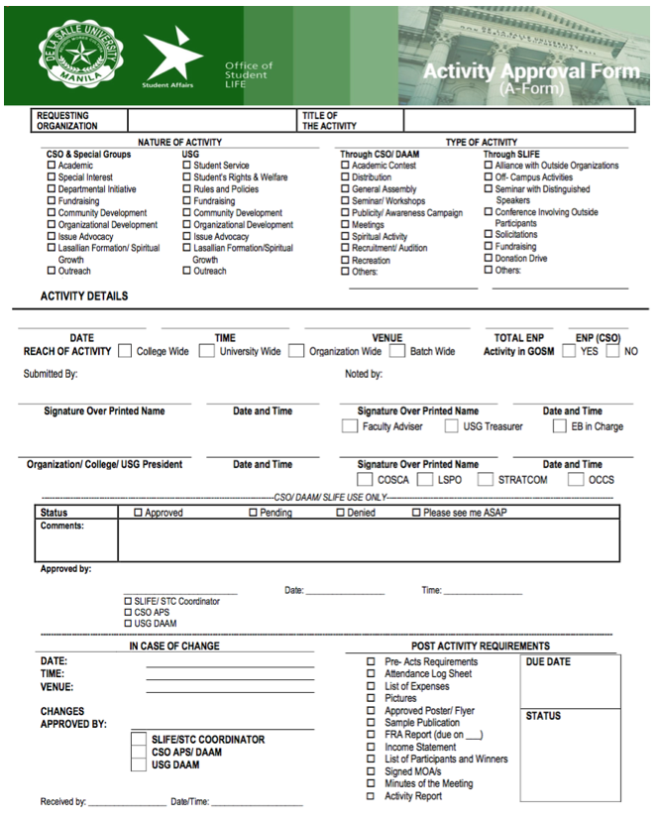

Memorandum of Agreement (MOA)

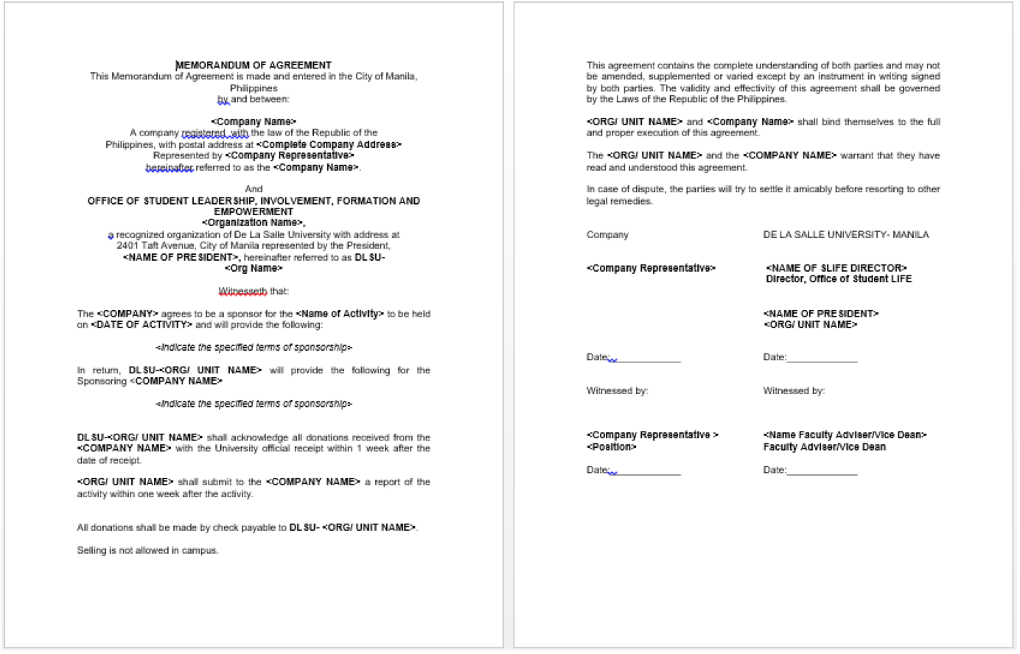

Project Proposal Form (PPR)

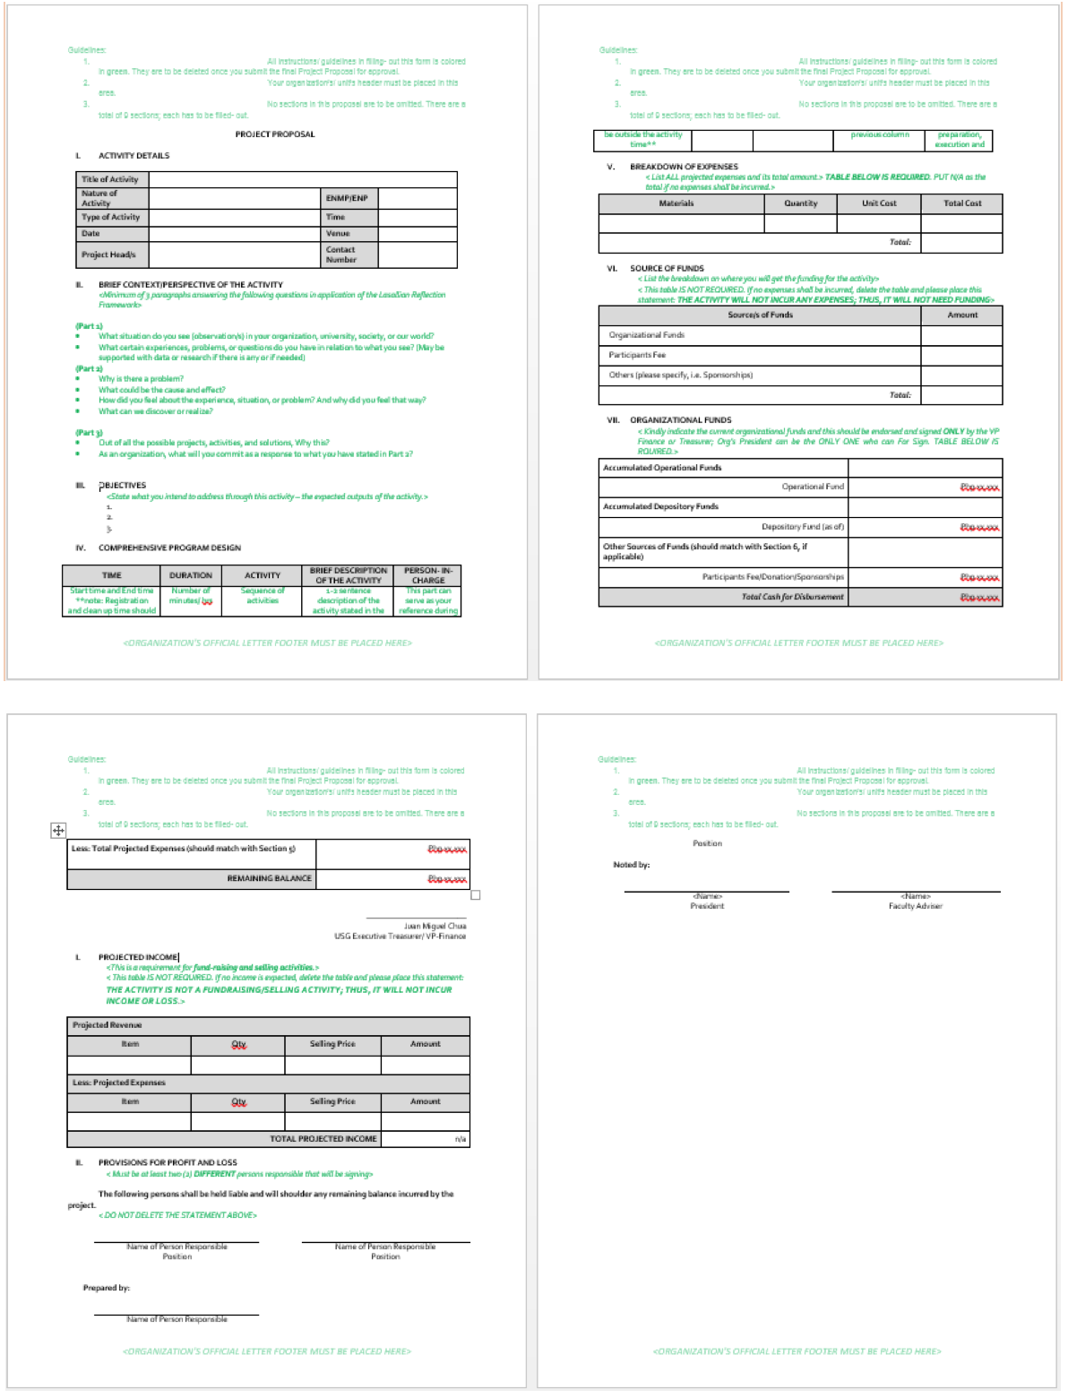

**Other Pre-activity Requirements**

Application for Use of Trademark

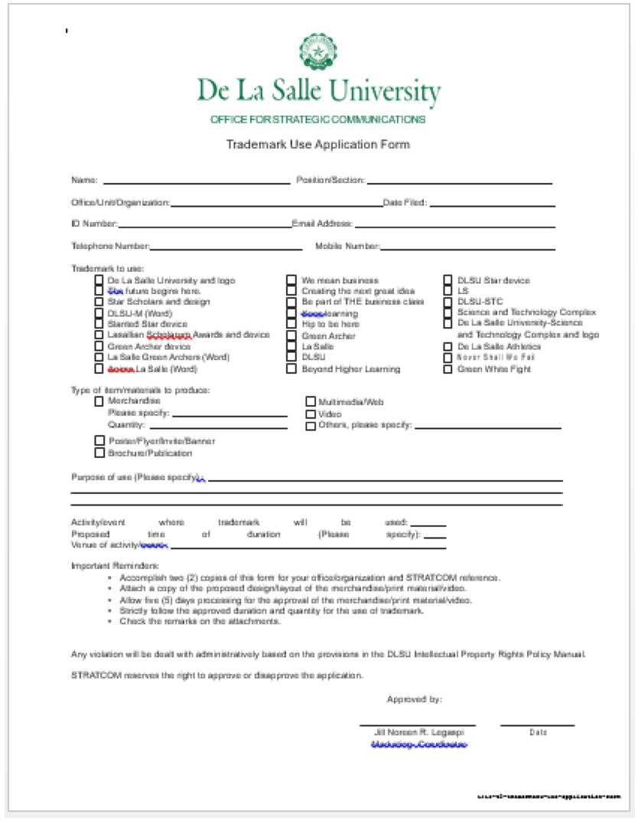

Approval Sheet for Minor Publications

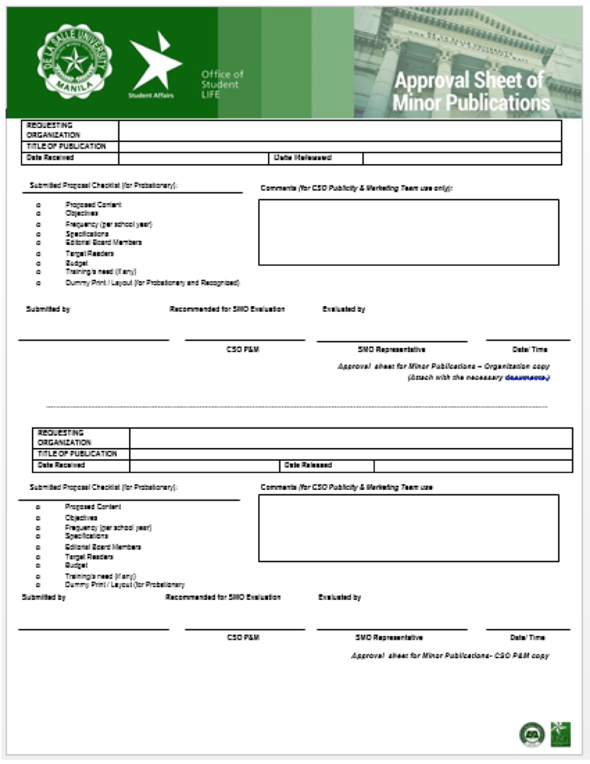

Faculty Conforme Form (FCF)

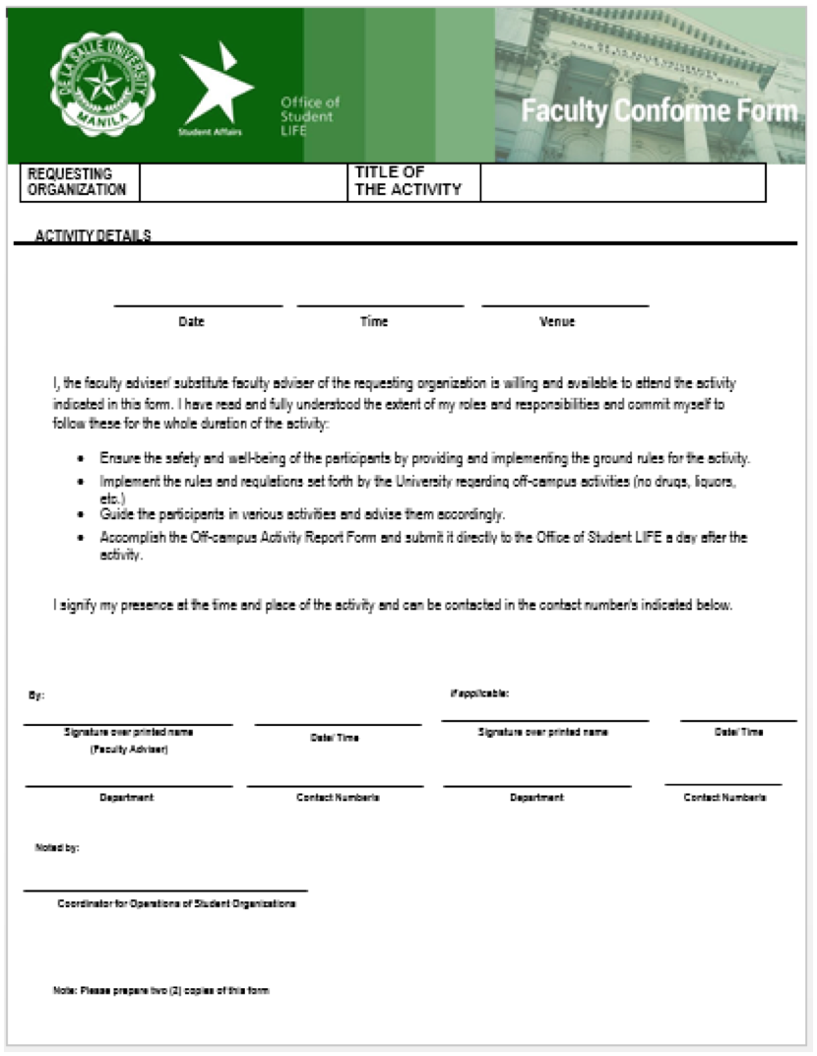

List of Participants (LOP)

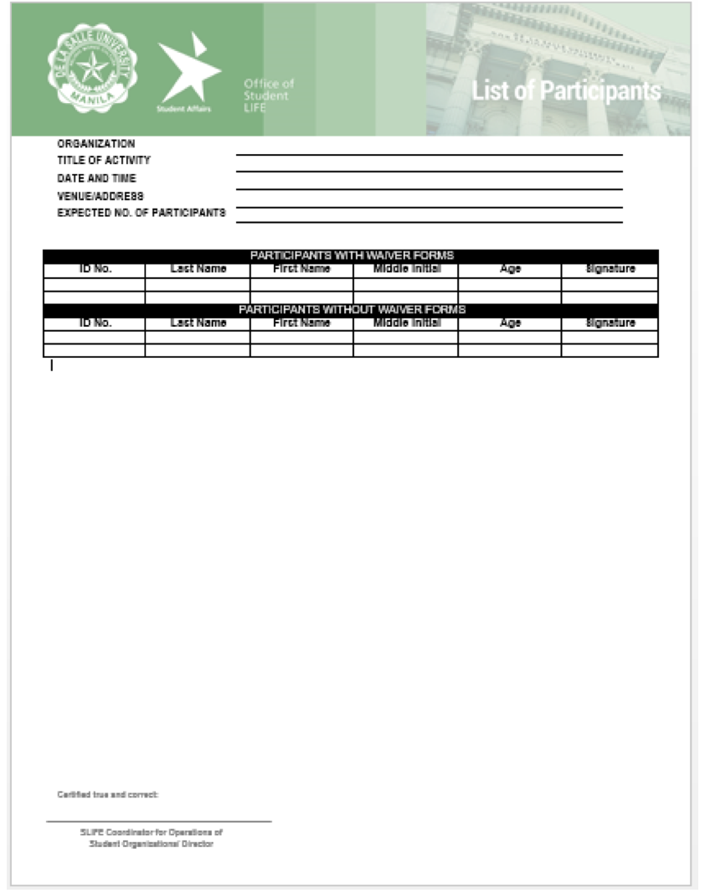

Minor Publication Proposal

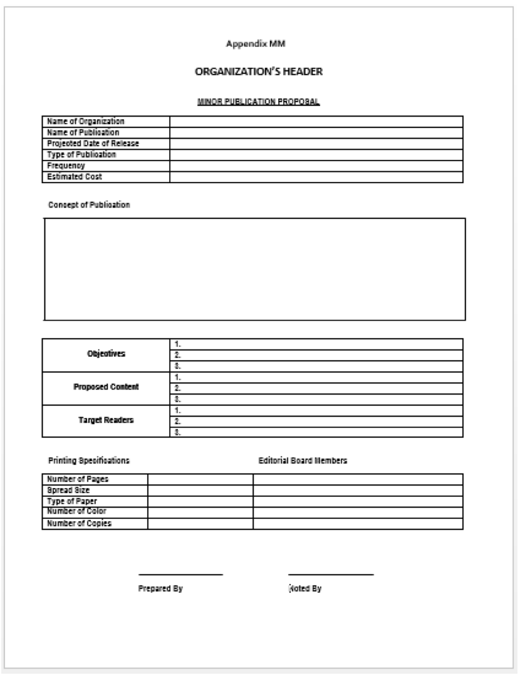

Solicitation Letter Format



**Post-Activity Requirements**

Activity Report

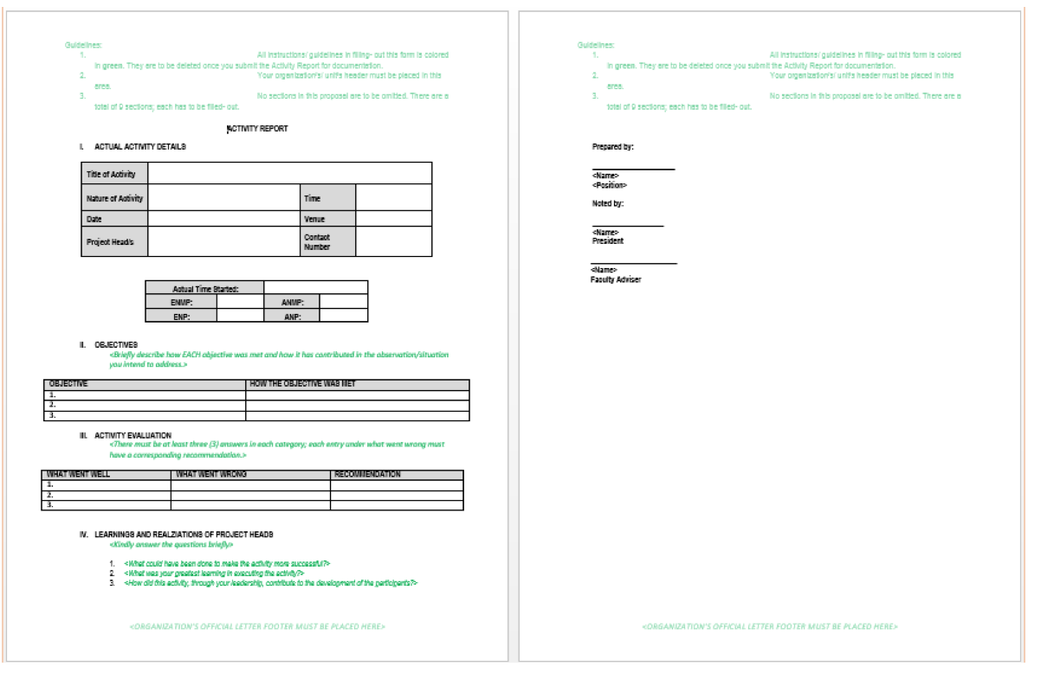

Fundraising Activity Report (FRA Report)

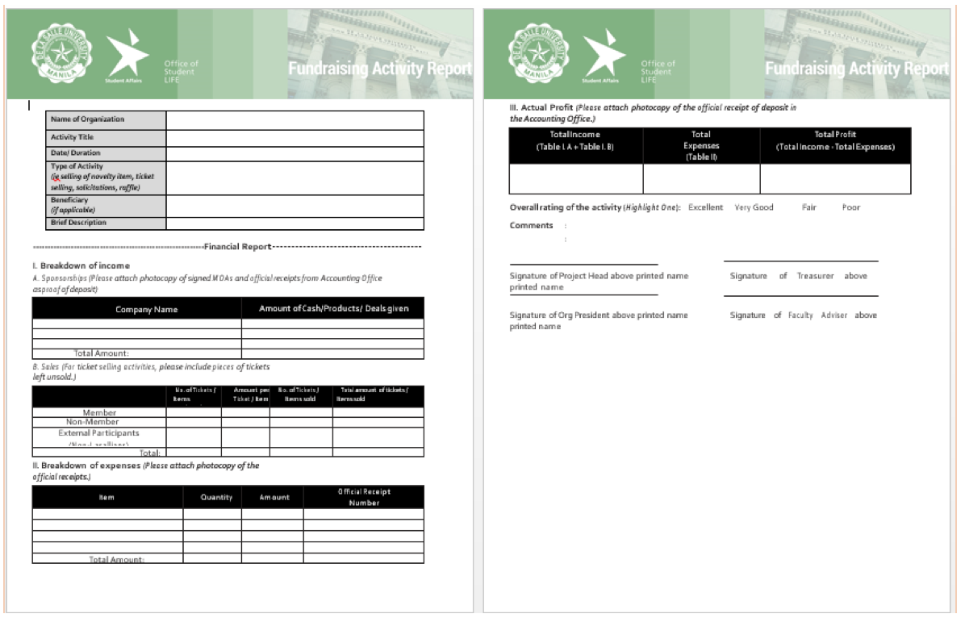

Media Activity Report

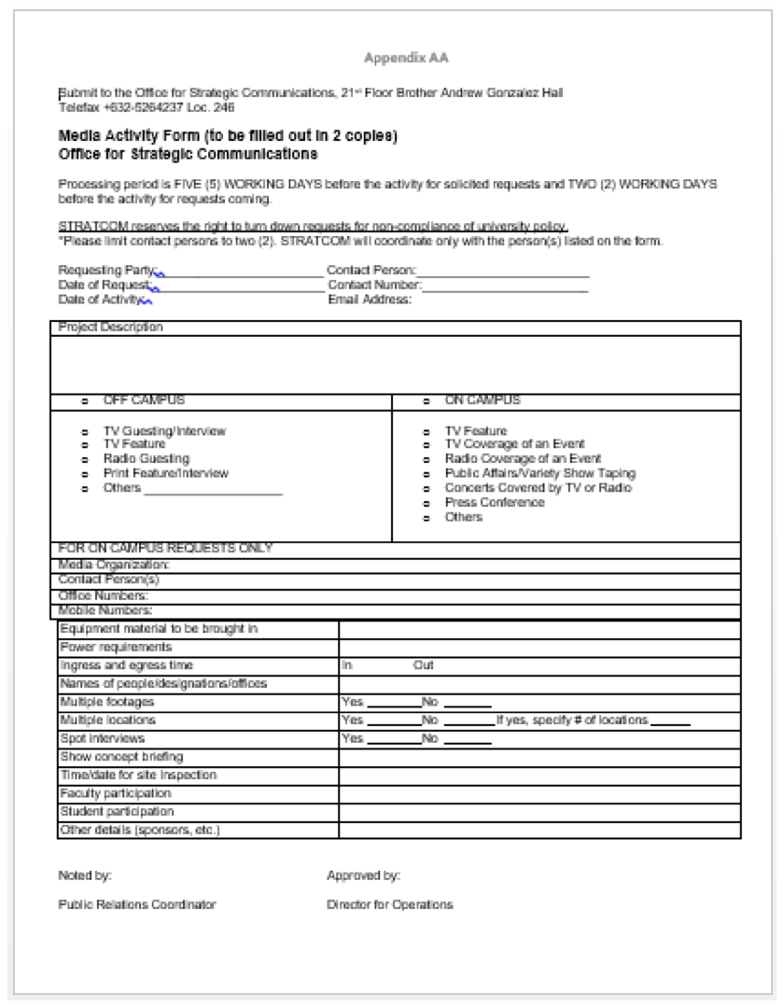

**Appendix D - Requirements Checklist**

|  |  |  |
| --- | --- | --- |
| **PROCESSED THROUGH OFFICE OF SLIFE** | | |
| **Activity Type** | **Pre - Activity Requirements** | **Post - Activity Requirements** |
| **Acquaintance Party (On-Campus)** | Detailed Program Design in PPR | Attendance Log Sheet, List of Expenses, Activity Report, Pictures |
| **Concerts** | Unsigned Memorandum of Agreement, Detailed Program Design in PPR | List of Expenses, Activity Report, Pictures, Approved Memorandum of Agreement |
| **Contests** | Mechanics | Attendance Log Sheet, List of Expenses, List of Winners, Activity Report, Pictures |
| **Food Fest** | Mechanics | List of Expenses, Activity Report, Pictures |
| **Fund-Raising Activity (Nature Dependent)** | Projected Income in PPR | Attendance Log Sheet, Activity Report, FRA Report, Income Statement |
| **Medical / Dental Mission** | Signature of COSCA Representative in A-Form, COSCA Form, Unsigned Memorandum of Agreement with Medicine/Medical Service Providers, List of Medicines/Services to be Provided, Off-Campus Activity Requirements (Faculty Conforme Form, List of Organizers, Waiver Forms of Organizers) | Attendance Log Sheet, List of Expenses, Activity Report, Approved Memorandum of Agreement, Evaluation Results, Names of Doctors/Nurses/Dentists, List of Patients/Participants, Pictures |
| **Novelty Item Selling** | List of Items with Pictures to be Sold, Signature of STRATCOM Representative in A-Form, STRATCOM Application Form for DLSU Trademark | Attendance Log Sheet, Activity Report, FRA Report, Income Statement, Pictures |
| **OCCS-Sponsored Seminar** | Signature of OCCS Representative in A-Form, Unsigned Memorandum of Agreement with OCCS | Attendance Log Sheet, List of Expenses, Activity Report, Approved Memorandum of Agreement, Evaluation Results, Pictures |
| **Outreach** | Signature of COSCA Representative in A-Form, COSCA Form, Unsigned Memorandum of Agreement, Off-Campus Activity Requirements (Faculty Conforme Form, List of Organizers, Waiver Forms of Organizers) | Attendance Log Sheet, List of Expenses, Activity Report, Approved Memorandum of Agreement, Evaluation Results, Pictures |
| **Participation in Contest / Seminars / Variety Shows** | Description of the Activity that would be participated in | Attendance Log Sheet, List of Expenses, Activity Report, Pictures |
| **Party** | Off-Campus Activity Requirements (Faculty Conforme Form, List of Organizers, Waivers of Organizers), Unsigned Memorandum of Agreement for Venue Reservation | Attendance Log Sheet, Activity Report, Pictures, FRA Report, Income Statement, Approved Memorandum of Agreement, Evaluation Results |
| **Press Conference** | Media Activity Form, Unsigned Memorandum of Agreement, Signature of STRATCOM Representative in A-Form | Attendance Log Sheet, List of Expenses, Activity Report, Pictures, Approved Memorandum of Agreement |
| **Radio / Press / TV Coverage of an Event** | Media Activity Form, Unsigned Memorandum of Agreement, Signature of STRATCOM Representative in A-Form | List of Expenses, Activity Report, Approved Memorandum of Agreement |
| **Raffles** | Mechanics, Projected Income in PPR, Ticket Design, List of Prizes | Attendance Log Sheet, Activity Report, FRA Report, Income Statement |
| **Recollection / Retreat (Off-**  **Campus)** | Signature of LSPO Representative in A-Form,  Faculty Conforme Form, List of Participants, Waiver Forms | Attendance Log Sheet, List of Expenses, Activity Report, Pictures |
| **Scholarship Grant** | Mechanics | List of Expenses, Activity Report, Pictures |
| **Solicitations** | Solicitation Letter, Sponsorship Packages, List of Prospect Companies, Unsigned Memorandum of Agreement with Prospect Sponsors | Activity Report, Income Statement, FRA Report, List of Sponsors, Approved Memorandum of Agreement |
| **Sports Fest / Tournaments (Off-Campus)** | Mechanics, Faculty Conforme Form, List of Participants, Waiver Forms | Attendance Log Sheet, List of Expenses, Activity Report, List of Participants and Winners, Pictures |
| **Teambuilding (Off-Campus)** | Complete Description of Activities, Off-Campus Activity Requirements (Faculty Conforme Form, List of Participants, Waiver Forms), Unsigned Memorandum of Agreement for Venue Reservation | Attendance Log Sheet, List of Expenses, Activity Report, Approved Memorandum of Agreement, Pictures, Evaluation Results |
| **Ticket Selling** | Projected Income in PPR, Ticket Design | Attendance Log Sheet, Activity Report, FRA Report, Income Statement |
| **TV Interview** | Media Activity Form, Unsigned Memorandum of Agreement, Signature of STRATCOM Representative in A-Form | List of Expenses, Activity Report, Pictures, Approved Memorandum of Agreement |
| **TV / Radio Guesting** | Media Activity Form, Unsigned Memorandum of Agreement, Signature of STRATCOM Representative in A-Form | Attendance Log Sheet, List of Expenses, Activity Report, Pictures, Approved Memorandum of Agreement |
| **Generic Off-Campus Activity (Nature Dependent)** | Faculty Conforme Form, List of Participants, Waiver Forms | Attendance Log Sheet, List of Expenses, Activity Report, Pictures, Evaluation Results |
| **Generic Tie-Up Activity (Nature Dependent)** | Unsigned Memorandum of Agreement | Attendance Log Sheet, List of Expenses, Activity Report, Approved Memorandum of Agreement |

|  |  |  |
| --- | --- | --- |
| **PROCESSED THROUGH CSO – APS** | | |
| **Activity Type** | **Pre - Activity Requirements** | **Post - Activity Requirements** |
| **Assistance (On-Campus)** |  | Attendance Log Sheet, List of Expenses, Activity Report, Pictures |
| **Audition** | Mechanics | Attendance Log Sheet, List of Expenses, Activity Report, Pictures, Results of Audition |
| **Awarding / Recognition** | Sample Publicity Visuals approved by the Publicity and Marketing Team (if the activity is a publicity in nature), URL (if online) | Attendance Log Sheet, List of Expenses, Activity Report, Approved Publicity Visual by the Publicity and Marketing Team (if the activity is a publicity in nature), Pictures (if the activity is not a publicity in nature) |
| **Awareness Campaign / Publicity / Announcements / Brochure Distribution** | Sample Publicity Visuals approved by the Publicity and Marketing Team, URL (if online) | List of Expenses, Activity Report, Approved Publicity Visual by the Publicity and Marketing Team |
| **Book / Materials Lending** | List of Books/Materials to be lent, Approval Letter signed by the University Bookstore Representative (for books and materials available in the university bookstore) | Attendance Log Sheet, List of Expenses, Activity Report |
| **Booth** | Labelled Booth Design | Attendance Log Sheet (if the booth is an interactive booth), List of Expenses, Activity Report, Pictures |
| **Bulletin Board** | Bulletin Board Design | List of Expenses, Activity Report, Pictures |
| **Contest / Competition / Amazing Race – Academic (Host Organization)** | Mechanics, Letter for Use of Different Venues in Campus approved by the Associate Vice President for Facilities Management (for amazing race type of activity), URL (if online) | Attendance Log Sheet, List of Expenses, Activity Report, List of Participants and Winners, Evaluation Results, Pictures |
| **Contest / Competition / Amazing Race – Non-Academic / Sports / Tournament (Host Organization)** | Mechanics, Letter for Use of Different Venues in Campus approved by the Associate Vice President for Facilities Management (for amazing race type of activity), URL (if online) | Attendance Log Sheet, List of Expenses, Activity Report, List of Participants and Winners, Pictures |
| **Distribution of Membership / Track / Frequency Cards** | Sample Design (front and back) | Attendance Log Sheet, List of Expenses, Activity Report |
| **Distribution of Reviewers / Academic Aid** | Sample Reviewer/Academic Aid, URL (if online) | Attendance Log Sheet, List of Expenses, Activity Report |
| **Donation** | List of Items to be collected/bought for Donation, Signature of COSCA Representative in A-Form, COSCA Form | Attendance Log Sheet, List of Expenses, Activity Report, Pictures, List of Collected Items (if the donations will be collected) |
| **Election of Officers** | Mechanics, Application Forms | Attendance Log Sheet, List of Expenses, Activity Report, List of Participants and Winners, Pictures |
| **Evaluation / Survey** | Sample Survey/Evaluation Questionnaire, URL (if online) | List of Expenses, Activity Report, Evaluation/Survey Results |
| **Exhibit** | Labelled Exhibit Design | List of Expenses, Activity Report, Pictures |
| **Film Showing** | List of Movie/s with Description | Attendance Log Sheet, List of Expenses, Activity Report |
| **Focus Group Discussion** | Agenda/Topics to be discussed | Attendance Log Sheet, List of Expenses, Activity Report |
| **Freedom Wall** | Wall Theme | List of Expenses, Activity Report, Pictures |
| **General Assembly** | Detailed Program Design in PPR | Attendance Log Sheet, List of Expenses, Activity Report, Evaluation Results, Pictures |
| **Interview / Screening** | Mechanics, Interview Questions | Attendance Log Sheet, List of Expenses, Activity Report |
| **Meeting** | Agenda | Minutes of the Meeting |
| **Miting de Avance** | Mechanics | Attendance Log Sheet, List of Expenses, Activity Report, Pictures |
| **Recruitment / Application of Officers** | Sample Application Form, Mechanics, URL (if online) | Attendance Log Sheet, List of Expenses, Activity Report |
| **Release of Publication / Online Publication** | To APS: URL (for online release)  To P&M: Minor Publication Proposal Paper, Minor Publication Approval Sheet, Dummy Print | List of Expenses, Sample Publication, Activity Report |
| **Seminar / Talk / Forum / Workshop / Orientation / Convocation / Training Workshop** | Credentials of Speakers | Attendance Log Sheet, List of Expenses, Activity Report, Evaluation Results, Pictures |
| **Spiritually Renewing Activity (Mass / Retreat / Recollection)** | Signature of LSPO Representative in A-Form, LSPO Form (if needed) | List of Expenses, Activity Report |
| **Study Group** |  | Attendance Log Sheet, List of Expenses, Activity Report |
| **Suggestion Box** |  | List of Expenses, Activity Report |
| **Teambuilding (On-Campus)** | Mechanics/Description of Activities, Letter for Use of Different Venues in Campus approved by the Associate Vice President for Facilities Management (if multiple venues will be used) | Attendance Log Sheet, List of Expenses, Activity Report, Pictures |
| **Training Program / Succession Program / Simulation** | Mechanics, Specific Plans/Activities to be done for the Program | Attendance Log Sheet, List of Expenses, Activity Report, Pictures |
| **Tutorial / Consultation / Mentoring** | Credentials of Tutor/Consultant/Mentor, List of Subject/s to be discussed/tutored (for tutorial), URL (if online) | Attendance Log Sheet, List of Expenses, Activity Report, Pictures |
| **Website (Launch / Maintenance)** | URL | List of Expenses, Activity Report |
| **General Online Activity (Nature Dependent)** | URL, Sample Publicity Visuals approved by the Publicity and Marketing Team (if the activity is a publicity in nature) | List of Expenses, Activity Report, Approved Publicity Visual by the Publicity and Marketing Team (if the activity is a publicity in nature) |
| **Series Activity (Nature Dependent)** | Series Title: Specific title of that activity in the series (For example, Training Program: Phase 1) | Attendance Log Sheet, List of Expenses, Activity Report, Pictures |

**Appendix E - References and Acknowledgment**

**References**

De La Salle University: Student LIFE: Online Forms. (n.d.). Retrieved from

http://www.dlsu.edu.ph/offices/osa/student_life/forms.asp

Student Activities Manual. (n.d.). Retrieved from

http://www.dlsu.edu.ph/offices/osa/student_life/pdf/student-activities-manual.pdf

**Acknowledgment**

House of Megan would like to thank the CSG President, Miguel Torres, for taking a part of his busy schedule to accommodate us for interview. We would like to thank him for sharing with us all the relevant details regarding the organization and the processes inside and outside of it. And lastly, we would like to thank him for allowing us to help them by creating a software solution to the organization’s problems.